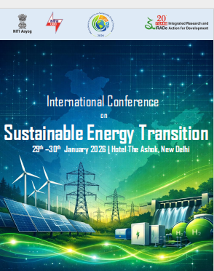


Contents
Session 1 – INAUGURAL SESSION 3
WELCOME ADDRESS BY KIRIT PARIKH, Chairman, IRADe 3
KEYNOTE ADDRESS BY P K MISHRA, Principal Secretary to the Prime Minister of India 5
VOTE OF THANKS BY JYOTI PARIKH, Executive Director, IRADe 10
Session 2 – INNOVATIVE STRATEGIC PLANNING FOR ENERGY TRANSITION 11
OPENING REMARKS 11
XUMING ZHANG, Secretary General, World New Energy Vehicle Development Organization(WNEVDO) and Executive Secretary General, China Society of Automotive Engineers 12
SURBHI GOYAL, Senior Energy Specialist, World Bank 15
RAJIB MISHRA, Executive Director (Designate), IRADe 20
Session 3 – EXPANDING GENERATION 21
OPENING REMARKS 21
DEB CHATTOPADHYAY, Senior Energy Specialist, World Bank 21
RATHIN BASU, Chairman & Independent Director, GE Vernova T&D India 22
RAJIV PORWAL, Director, Grid Controller of India Limited 24
ANIL KAKODKAR, ex-chairman, Atomic Energy Commission of India 26
Session 4 – EXPANDING GENERATION 30
OPENING REMARKS 30
YOUBA SOKONA, Former Vice-Chair, Intergovernmental Panel on Climate Change 31
SUVENDU BOSE, Senior Advisor to Ministry of Energy, UAE 32
FRANCISCO GAFARO, Team Lead-Power Sector Transformation, IRENA, Germany 34
PANKAJ BATRA, Senior Advisor, IRADe 36

DAY 1

Session 1 – INAUGURAL SESSION
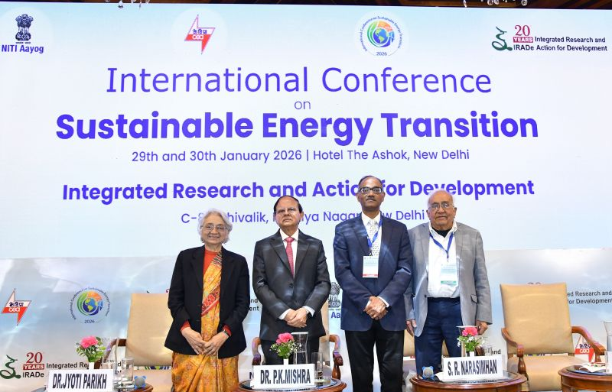

WELCOME ADDRESS BY KIRIT PARIKH, Chairman, IRADe
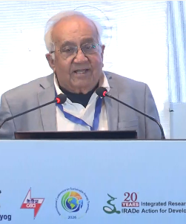
All developing countries are facing a dilemma - they need to grow, since economic growth is necessary for increasing well-being and human development and at the same time, think about decarbonization. Developing countries have made a very small contribution to the global climate change threat but, many of them are highly vulnerable to climate change. So, decarbonization is necessary in their own interest, not only in the long term, but also in short term.

Many of us are short of fossil fuels, and depend on the imports of fossil fuels to a great extent. Local air pollution has been a major problem in many cities in India and in other countries. The annual economic cost of local air pollution in Delhi is 90,000 to 120,000 crores is the annual economic cost of Delhi's air pollution which is about 12.5 billion US dollars.

What can we do? What are our decarbonization options? The most important would be in the electricity sector which needs changes and technology adaptation. Renewables like solar, wind, hydro, biofuels have to be expanded as they emit no CO2. And storage for renewables is also very critical. We need to have, either battery-based storage or pumped hydro power plants. So a lot of investment would be required.

We can also think about improving efficiency. But, improving efficiency of energy use requires actions by consumers, as well as by producers. We should also need to promote clean technologies, non-fossil fuel based - it could be nuclear, hydrogen, and even carbon. Coal can be used with a CCUS, that is carbon capture use and storage kind of system, which can provide us clean technologies and clean energy. With such investments also lead to changes in the sectoral composition of the economy, leading to a change in the GDP. It leads to more income of the consumers, and their demand patterns might also change, bringing about changes in employment. We have a significant amount of coal mining and use in various sectors, and a large number of people employed in coal industry, coal sector, in mining, in transport, would be affected.

We want to have a Viksit Bharat or Developed India by 2047, growing at 8% per year along with a net-zero energy economy by 2070, we need to think about the various options that we have. IRADe has done a number of studies where we have been using models which capture these demand changes, capture the structural change in the economy, and capture also the investment requirement and GDP growth rate. In the business-as-usual, there is no further change in policy from now till 2070 and we will need close to 11,500 terawatt hour of electricity in 2070. But if you go to renewables and storage, we will need 18,000 terawatt hours.

Why do we have this large jump? If you have renewables, a lot of storage is required, and the energy that you put in and energy you get out, that is about 20-25% loss. This is also reflected in the investment in the capacities, from 2100 TW in the business-as-usual scenario to 6000 TW in the 2070 net zero scenario. If you want to replace 1 MW of coal, you need to invest in 4 MW of solar, because a coal-based plant can run for 80% of the time, and a solar is 18-20% of the time. So, that itself increases the investment requirement. In these scenarios we have assumed that whatever finance you need is available. But if finance is not available, then GDP and demand both will go down. So we have to recognize the importance of finance is crucial.

We need to develop a strategy for India to have a holistic understanding of the whole ecosystem, which is very complex. We have to understand how DISCOMs can function, given the fact that a large amount of renewable today remains unsold. It is reflected in the fact that a couple of months ago, the power price on the power exchange board was less than 3 paisa in the midday and it was more than 10 rupees in the evening hours so that there is this whole fluctuation of availability and demand match. So finance becomes very critical, and we need to think about what are the incentives for investors and what are the incentives for consumers to use less electricity and to produce it in a more economical or efficient way. Market structures and business models are also required for producers and even for prosumers in terms of policies, subsidies, tariffs, etc. Here, international experience might help us and in this conference, we have people from 9 different countries going to address us about their experience on energy transition.

One final statement that is required is political feasibility. As analysts, we cannot really say what the political feasibility is. And so experts and professionals, like Dr. P.K. Mishra, should certainly define what is politically feasible and what is not. Dr. P.K. Mishra is the principal secretary to the Prime Minister, and he has been with him for many years, including in Gujarat. You can see that the kind of support he has provided to the Prime Minister has led to many innovative ideas. He clearly has a comprehensive understanding, and he has played a critical role in many of these things. I am delighted that he has agreed to give us his inaugural address. Thank you very much.

KEYNOTE ADDRESS BY P K MISHRA, Principal Secretary to the Prime Minister of India
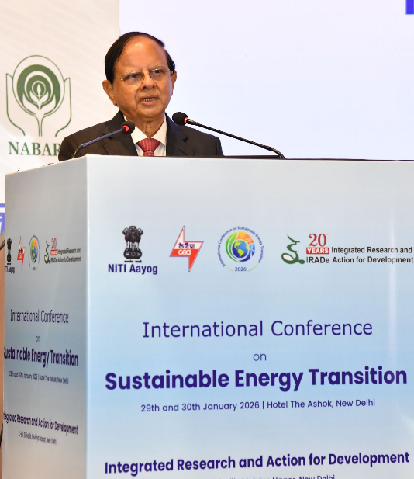
Good morning to you all.
Dr. Kirit Parikh, Mr. Narsiman, Dr. Jyoti Parikh, distinguished delegates, ladies and gentlemen.
I'm delighted to address this international conference on sustainable energy transition at a time when the global system is undergoing one of the most profound transformations in recent history. The challenge before us, or before the world, is not merely technological, it is economic, social, and institutional and it has a political dimension as well.

It is always nice to come to a conference or gathering like this which addresses issues of power sector. Because I have been in the power sector for almost a decade and I still remember my days in the Gujarat electricity Regulatory Commission, and, before that, in the Gujarat Electricity Board as Member Finance. But today, the challenges are much more, particularly in the context of Climate change-related issues.

Achieving climate goals while ensuring energy security, affordability, and universal access remains a defining challenge, particularly for developing and emerging economies. For the Global South, this transition must be just, Inclusive and Development Aligned. Recognizing their differentiated responsibilities, national circumstances, and the need for sustained international cooperation, there are many dilemmas. We need economic growth and at the same time, often, there may be some trade-off between energy transition and economic growth, but there need not be, as I will explain later.

For India, energy transition is integral to our broader national aspirations of building a Viksit Bharat 2047, both as a rapidly growing economy. and a country deeply vulnerable to climate impact. But at the same time, we need to accelerate our economic growth. In the last decade, India's economy has undergone a remarkable transformation, reaching a GDP of around US dollar 4.2 trillion. It is now the world's fourth largest economy driven by macroeconomic stability, institutional reforms and the rise of digital public infrastructure.

Between 2015 and 2025, India contributed nearly 15% of global GDP growth, supported by strong domestic demand, and continuous policy reforms. India has set a goal of becoming a developed country. Our Prime Minister has articulated a vision of a developed India that cares for both nature and culture, adopts and advances technology; and aspires to be thought leader in science and innovation. In that vision, India will be Atmanirbhar in all critical sectors. Women will lead India's developing story. The economy will be more inclusive and innovative. Corruption, casteism, and communalism will have no place in our national life. This is the vision of our “Viksit Bharat” for us.

The goal is being pursued in a global context, marked by turbulence. The devastation caused by the COVID-19 pandemic, trade wars between large economies. geopolitical tension, the challenges of climate change and energy transition; disruptive technologies such as artificial intelligence and resurgence of protectionism. So, these are some of the challenges which we need to address. while accelerating our economic growth, and among all these, possibly, the climate-related issues, climate change aspect and energy transition are very, very important. Despite all this uncertainty and complexity, India's fundamentals remain strong. Recent data indicate a real GDP growth for the year 2025 and 2026 of 7.4% compared to 6.5% in the previous year. And India is one of the largest countries growing faster than other countries.

At the same time, India faces a stark climate reality. India represents about 17% of global population. but it accounts for only 4% of cumulative historical carbon dioxide emission. India's per capita CO2 emissions are about 2 tons, less than half of global average, and about 1 tenth of that of advanced countries. India is among the most vulnerable nations to climate impacts. Agriculture, employing about 400 million people, is acutely sensitive to temperature and rainfall variability. Coastal region face risk because of all this climate impact. Water security is threatened by altered precipitation and glacial melt. This divergence of risk responsibility and response has shaped India's principal stance on climate and energy.

As our Prime Minister, Narendra Modi, stated at the UN Climate Conference in Paris, “Climate change is a matter of climate justice. Those who have contributed least to the problem are suffering the most”. India has already reduced the emission intensity of GDP by about 36% between 2005 and 2020; and become the first G20 country to meet its Paris Agreement commitments 9 years ahead of the 2030 timeline. It is against this backdrop that we must view India's energy transition strategy.

I would like to focus on some of the measures which government of India has taken in the recent decade in this direction. India's energy transition objectives encompass several interdependent objectives - transitioning to low-carbon energy sources; ensuring energy security, and meeting the requirement of rapid economic growth. Rapid expansion of renewable energy forms a part of this strategy.

In 2014, renewable energy accounted for about 30% of the total installed capacity, about 80 GW, which included all solar, wind, Hydro, etc. Solar power capacity was only 3 GW about a decade ago. At the same time, more than 400 million people required reliable access to electricity and the aspirations of Abhikshid Bharat implied sharp increase in energy demand. India's initial strategy focused on rapid expansion of renewable energy capacity and the creation of a robust policy framework. I remember in 2009-10, when I was in the Gujarat Electricity Board. the solar capacity, solar energy installed capacity was not even 1 GW. It is amazing how those days we used to struggle to increase the solar energy capacity even by a few megawatts, and now how things move very fast, technology developed and of course, the pricing of solar energy is another story which can say how technology and social change can help improve growth.

Acceleration of National Solar Mission. with solar targets scaled up to 100 GW, transforming it into a cornerstone of India's NDC implementation. The Ultra Mega Solar Parks Scheme, announced in December 2014, and expanded in February 2017, addressed land transmission and clearance bottlenecks by providing common infrastructure within designated parks. This reduced project risk and compressed execution timelines also. So this was one of the major initiatives, which had helped us in augmenting all our solar energy capacity.

Another measure which was taken was the amendment to the national tariff policy in 2016, which brought several key changes, mandating competitive bidding for solar power and enhanced renewable purchase obligation trajectory, and the waiver of interstate transmission charges for solar and wind power encouraged adoption of renewables.

These were complemented by grid expansion and competitive approaches, like auctions. As a result, India has now achieved over 135 GW of Solar capacity, and 52% of cumulative installed capacity from non-fossil fuel sources ahead of its various timelines.

Diversification of energy sources has also contributed to decarbonization and energy security. The national policy on Biofuels, announced in 2018 has accelerated ethanol blending to 20% from hardly 1% a few years ago. This has led to avoidance of an estimated 80 million tons of carbon dioxide emission, along with foreign exchange savings of about 20 billion US dollar, and transfer of roughly US dollar 15 billion to farmers as feedstock supplies, because when we encourage ethanol blending, more ethanol is produced and that helps farmers selling their food grains, and they get higher profit.

Another initiative, the National Hydrogen Mission announced by the Prime Minister on the Independence Day 2021 has signaled a shift towards green hydrogen as a means to decarbonize the economy and reduce long-term fossil fuel imports. India has also undertaken a historic reform by opening the nuclear energy to private participation, through recent legislative initiative. This is expected to scale up nuclear capacity significantly by 2047, and provide farm zero-carbon baseload power. Very recently, the Shanti Bill was passed, and it is a historic event, since for a long time, there were issues about expanding or opening up nuclear power to private sector because of various reasons, but a very bold step has been taken by the government of India. This shows the strong political will.

These measures align energy transition directly with energy security and import reduction, enhancing India's strategic autonomy. Some of these measures, whether it is green hydrogen, whether it is the nuclear power opening to private sector, ethanol blending and encouraging it for more production - all these can help economic growth, at the same time also help energy transition. So, the contradiction or the trade-off between them can be reduced. We can have both cleaner energy and higher growth.

I have so far mentioned about some of the macro-level or policy initiatives. But some measures have been taken which will lead to farmers' empowerment and rural transformation also, while achieving energy transition. India's energy transition is consciously designed to support rural livelihood and agricultural resilience. The PM Kusum scheme launched in 1919, It's emblemic of this approach with nearly 26 million diesel-based irrigation pumps in operation, the scheme has crafted to tackle emissions, subsidies, and farmer income simultaneously. With solar panels providing energy for the agricultural pumps, some of the achievements of PM Kusum are that 2 million irrigation pumps have already been solarized; diesel subsidy decreased by Rs. 6,000 crore annually; farmers sell surplus electricity to the grid, thereby enhancing their income, remote agricultural regions have enhanced energy access and reduced dependence on diesel. So this intervention has helped not only reducing carbon emission, but helping farmers increase income, and also having access to electricity in remote areas, along with having some surplus energy. PM Kusum thus exemplifies policy convergence, energy transition support, agricultural resilience, fiscal sustainability, and rural development in a mutually reinforcing manner.

The biofuel program further deepens this rural transformation by enabling the use of agricultural residues, damaged grains used for biofuel, and sugarcane derivatives for ethanol production. The national policy on biofuels has created additional income streams for farmers while strengthening India's energy security. In effect, energy transition in India is not an abstract decarbonization exercise, it is reshaping the economics of rural India.

Another aspect is how it also helps household welfare and energy access. Any development effort can be successful and meaningful if there is participation of the people. India has also extended the benefit of clean energy directly to households, turning consumers into active participants and producers in the energy system. India has already achieved near universal household electrification, ensuring that clean energy expansion coincides with social inclusion. Building on this, the PM Surya Ghar Mukt Bijili Yojana, launched in 2024, brings clean energy directly to the rooftops. The scheme targets adoption of renewable energy by about 10 million homes. By January 226, rooftop solar installation has already added several GWs of decentralized capacity. Households are transformed from passive consumers into pro-consumers participating in and benefiting from energy transition. Rooftop solar, even in the small houses, can help not only, reducing carbonization, but also giving some income to households which can generate surplus power from their rooftop solar installations. Demand-side initiatives, the Ujala Scheme, the LED program, and also, together with building codes and efficiency standards, these programs make energy efficiency a cornerstone of India's low-carbon development strategy.

India's transition is also delivering substantial emission reductions and establishing the country as a global climate leader. Between 2005 and 2020, India achieved 36% reduction in emissions, intensity of GDP, exceeding its Paris commitment, installed renewable capacity has increased nearly 8-fold in the past decade, from 30 GW to over 237 GW, making India one of the largest global players in solar and wind. At the COP26 in Glasgow, our Prime Minister announced that India would achieve net zero emissions by 2070. This commitment is to be realized through a pragmatic Panchamrit strategy which includes achieving non-fossil generating capacity of 500 GW by 2030. and reducing emission intensity of GDP by 45% from 2005 level. These were not abstract promises. By 2021, India had already deployed over 150 GW of renewables and significantly reduced emission intensity, demonstrating institutional capacity to meet ambitious targets.

Another measure which is internationally appreciated is the launch of the Lifestyle for Environment movement, which is a significant development, as it recognized that technology alone cannot deliver sustainability without behavioral change. The lifestyle for environment known as Life, L-I-F-E, seeks to embed sustainable lifestyles and consumption choices into everyday practice supported by policy nudges and community action. With these measures, India became the first G20 country to meet the Paris targets, well ahead of the schedule and now crossed 50% non-fossil install electricity capacity, again ahead of the timeline declared by India at the International Forum.

In the case of industrial competitiveness, India's energy transition has been integrated into its economic development strategy by aligning with the Make in India effort also. India will also become Atmanirbhar by manufacturing the equipment, the machineries which are required to generate Renewable energy. The production link incentive PLI scheme of solar, photovoltaic modules marked a decisive shift towards domestic manufacturing. Since 2022, solar module manufacturing capacity had an increase of about 82 GW within this short period of 3 years. This is complemented by support for advanced battery manufacturing and other clean energy supply chains, because storage is also very, very important. Complementary programs of FAME2 for electric mobility, the Perform, Achieve and Trade, or PAC scheme for Industrial Energy Efficiency and investment in transmission, HPDC corridors and storage strengthen system reliability while generating employment in construction, manufacturing, and services. Clean energy, therefore, is not peripheral to India's growth strategy. It is at the core of industrial competitiveness and technological leadership. Our green energy efforts will provide employment, will have higher manufacturing capability, and it will help economic growth.

At the international level also, the efforts made by India has been well recognized. India's strategy has a significant international dimension, particularly in shaping the global energy transition discourses from the perspective of the Global South. The founding of the International Solar Alliance at COP21 in Paris marked creation of the first multilateral climate institution initiated by a developing country. The ISA, or International Solar Alliance brings together 112 sun-rich nations, predominantly from the Global South, with India as a key convener and knowledge partner. The idea is to help Global South in promoting solar energy. India's commitment under Panchamrit, its early achievement of parish targets and launch of LIFE, a life program have strengthened its role as a global climate leader.

During the G20 presidency, which was very successfully coordinated by India and New Delhi, and other parts of the country, India used its platform to foreground the conscience of developing countries, particularly the risk of premature or disorderly transition without adequate finance and technology. The Prime Minister encapsulated this approach at the G20 Energy Ministers' meeting in Goa. India has consistently argued for recognition of differentiated responsibilities, enhanced climate finance, and meaningful technology transfer. Its own experience shows that ambitious energy transition is feasible even in a large developing economy, provided policies are tailored to the developmental realities.

There are a few emerging challenges. As renewable energy increases, system, reliability. and grid stability become more complex. India has responded through greater investment in transmission, including SBTC corridors and scaling of storage solutions. These are two areas which need more focus, the transmission capability, transmission infrastructure, and scaling of storage infrastructure. However, more work needs to be done in these two areas.

The just transition for coal-dependent region must be carefully managed. Coal will continue to play a role in ensuring energy security in the near term. India's approach acknowledges this reality while steadily reducing emission intensity and exploring options such as coal gasification and diversification of regional economies. While making all efforts for energy transition in the short run, we need to also diversify our coal use by gasification and a few other measures for the short term.

Climate finance and technology access remain major constraints for the Global South. Developing countries face ambitious emission reduction expectations without commensurate support. India has consistently maintained that climate action must be rooted in equity and climate justice, and the adequate predictable and affordable finance is necessary.

So, clean energy is deeply embedded in India's vision for Vixit Bharat. It is no longer a sectoral agenda. It is central to our growth story. Competitiveness, and social inclusion, and of course, energy security that the Prime Minister observed during the India Energy Week. He said, “A developed India will be built on clean energy, green growth, and sustainable lifestyle. A developed India would be built on clean energy, green growth, and sustainable lifestyle”.

- Ambitious targets gain credibility only when supported by institutional architecture, Sustained financial commitment and consistent execution. It is not enough to have only a very ambitious target. We need to have the institutional architecture, sustained financial commitment, and consistent execution. India's ability to achieve 50% clean energy by 2025, instead of 2030 and 100 GW of solar power well ahead of earlier expectations demonstrates the importance of policy continuity and institutional strength.
- Energy transitions are more durable when they deliver tangible welfare gains. PM Kusum's impact on farmers, PM Surya Ghar's relief for households and the jobs created through solar manufacturing and electric mobility show that decarbonization and development can reinforce, rather than undermine each other. Our energy transition can be more durable, more sustained, if we involve people, as the example, PM Kusum with the farmers, PM Suryaghar for households. This can show that decarbonization development can go together. They need not undermine each other. There need not be a trade-off, also.

India is attempting something without historical precedent. Sustaining high growth while reducing emission intensity within a single generation. It is not an easy path, but it is grounded in responsibility, realism, and resort. It is grounded in responsibility, realism, and resolve. We are rapidly moving towards a goal of 500 GW of non-fossil capacity by 2030 and towards Viksit Bharat 2047, built on clean energy, green growth, and sustainable lifestyle.

I wish the conference all success in advancing informed, inclusive, and actionable solutions for a sustainable global energy future. Thank you very much.

VOTE OF THANKS BY JYOTI PARIKH, Executive Director, IRADe
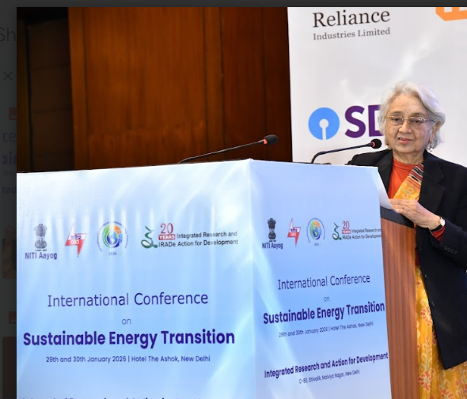
Thank you very much, Mr. PK Mishra, for joining us.
His contribution in disaster resilience is well-known in Gujarat.
We just celebrated 25th anniversary of Kutch disaster, where he played a major role. Gujarat was the first state to set up a disaster management agency, which handles no matter which disaster. They are prepared to, go in a team with professional approach. And, that model is now replicated in every state. He set up a Coalition for Disaster Resilience Initiative, CDRI, which is an international body operating from India.
Over the last 20 years, energy transition is taking us from fossil fuel-dominated autocracy to renewable energy-based democracy. This transition encourages all players, on the scene, ranging from solar, wind, hydro, biofuels, and also, fossil and nuclear. Instead of the few enterprises who manage fossil fuel chains, many more people in the country are getting involved. It is not just around mines and large power plants, but it's a participatory energy source. Further, new businesses are emerging around storage, both pumped hydro, the closed loop and the open loop, and battery-based, grid-scale battery-based, along with many efforts on transmission links, DISCOMs, and more. So there are institutions, businesses that have come into the play. It is not limited to the supply chain alone but also involves the demand sectors. People engage with renewable energy directly, and sometimes indirectly, unlike fossil fuels, where people merely turn switches on. Now people are interacting with the energy source themselves, as they wish to.
Electric vehicles, is another business altogether, reducing noise and air pollution. Also domestic appliances and convenient irrigation through PM Kusum where an average farmer is directly interacting with the solar panels. Consumers are now running home businesses and they can also choose the price which they wish to pay according to the level of reliability they need for their supply. We are fortunate to have a grid, which is very strong and unique, in the world. We have power markets that give prices every 15 minutes, so that people can respond accordingly. Choices to the customers are increasing, as well as to the suppliers. Such an energy system with many players can work, only if there are regulatory systems run by independent bodies, and participants also have to follow certain disciplines as democracy, cannot function without disciplines and, responsibilities of the participants.
Renewable energy system is not meant just for decarbonisation but also for energy independence. While it is necessary for those with larger carbon footprint, small islands and many small countries who do not have fossil fuels, are dependent on imported fuels. India also imports 80% hydrocarbon. So they prefer to have solar and wind power, especially small islands for their energy independence. Africa, may prefer distributed renewable energy when there is load sources to address, for households, small businesses. So, each, country has different reasons for the transition; decarbonisation, energy independence, pollution reduction in the cities.
We have, therefore, invited experts from other countries to the conference. Soon after this session, China will join us virtually. He would be speaking on the electric vehicle experience of China. We would also hear from Africa about their experience. IRENA will speak on how they are managing renewable energy. We will hear from, UK about their regulatory experiences, OFGEM which is like a CERC of India. We will hear their experiences, to see how each country sees renewable energy. Some are seeing as decarbonization, some are seeing as reducing energy independence, and these days, energy independence is getting more and more importance. It is also dragging foreign policy and other issues, together. People have choices now, and, will have more choices in the future. However, we have to also realize that, fossil fuels have served us in need, and they will have to remain for quite some time. Just as older generation keeps supporting the younger generations. We can see how society, industry, government, they all come together, to see this happen in an appropriate manner. The Indian government has taken a lot of efforts, made a lot of new suggestions in the international arena, and, shown what can be done, how to reduce carbon emissions while growing, because when you need more energy for growth, and yet you have to keep maintaining the, decarbonization process going.
I thank all the delegates for coming here. Thank you PK Mishra and all the panelists who are going to be with us over the two days. And, all the virtual participants are welcome.
I would like to thank my colleagues - Dr. Rajib Mishra, Dr. Sudipa Majumdar, Mr. Pankaj Batra, Mr. BK Sarkar, Mr. Mohit Gupta, Mr Naman Mehta, and many others. I'm grateful to all of them, for their continuous, efforts making this event successful in a very short time. We are also competing with events going on in Goa, and now the Budget is also coming up, but nevertheless, I'm glad to see the participants here and virtual participants.
Thank you.

Session 2 – INNOVATIVE STRATEGIC PLANNING FOR ENERGY TRANSITION

OPENING REMARKS
As we move forward, it is clear that achieving a clean, reliable, and affordable energy future will depend not only on ambition, but on innovation and strategic planning that can translate vision into implementation. The global energy transition today stands at a critical intersection where energy security, affordability, and deep decarbonization must progress simultaneously. This requires the forward-looking policies, advanced technologies, and new business models, and integrated planning approaches across the power, transport, industry, and markets. This session, which is titled Innovation, Strategic Planning for Energy Transition, will focus on how innovative solutions and strategic frameworks can accelerate the global energy transition. The discussion will bring together perspectives from regulators, global institutions, industry, and international organizations, offering a comprehensive view of how innovation can be effectively deployed on the ground.
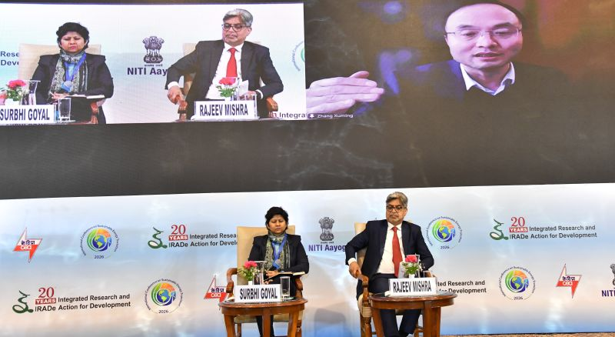

XUMING ZHANG, Secretary General, World New Energy Vehicle Development Organization(WNEVDO) and Executive Secretary General, China Society of Automotive Engineers

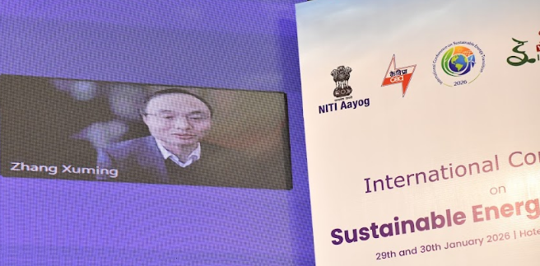
Thank you for the invitation, and I'm very glad and honored to be here to join you virtually, for this important conference. I have been working for the auto industry for many years, so I would like to share my experience in the auto market, in the past 20 years for the new energy vehicles developed in China. I think this kind of experience might be valuable to other countries, so that we can see how we can decarbonize the transportation and to transfer towards a low-carbon energy.

China currently has the new engine vehicles, including the battery electric plug-in hybrid, electric vehicles, and also the fuel cells. So, they are now the dominant choice in China. Last year, almost 50% vehicle sales were new energy vehicles. If we look at passenger vehicles, that's around 55%, which is high and therefore, it is already the dominant choice in China. In the past 5 years, it increased from 5% to almost 50%, showing a very rapid growth. But, this is not easy and it has been a marathon.

In 2000, that's 25 years ago, China launched the EV R&D program and for 20 years, it grew only from 0% to 5%. The challenge is very big. The products and the technology, the dynamic driving performance, the technology, the affordability, the charging infrastructure, and another big challenge is the public awareness and acceptance.

To overcome the challenge, two points are important. The first one is strategic planning and policy consistency is critical. China has a long-term policy support to the new engine vehicles. We started in 2000, from the R&D program to address the technology readiness, including the battery, the motor, the control systems for the new engine vehicles. The power density of batteries increased many times, and its price and its cost dropped more than 90%. We are still expecting more cost reduction in the future, to look at this kind of policy support to the R&D to make the technology ready. Chinese government provided some funds to the R&D program, but I would say that, the government's funding is more like a seeding fund. The majority of the investment are from the industry, from the private sector. So, the seeding fund provide guidance and confidence to the industry and customers about the energy security in the future.

Then, in 2010, we moved to the early commercialization pilot program, to reduce the vehicle cost and to make it affordable. So, in 2010 we had subsidy to the customers, especially to the early users. Thus, 2010-2020, in 10 years the market expanded by 5%. Another important issue is about the charging. So together with the early commercialization, we started to build the charging infrastructure simultaneously. These had to be together and charging infrastructure has to come before the vehicle readiness.

We needed the policy support and innovation to reach our full electrification. So it's more than 20 years. Some companies had big success in the market, and some failed. But, during this long marathon towards the legislation. Looking to the future, we still need a lot of joint efforts for this transition towards electrification. The challenges with auto industry cannot be solved by the auto industry by itself. So transport electrification or transport decarbonization should be worked together with auto industry, with energy, with the transport and city planning, with the IT, with the AI, through collaboration.

For the energy side, we, in China we have the pilot program on the V2G, the vehicle grid integration, so that makes the charging and the vehicle closely linked, together with the power system. Hydrogen is another important aspect for the lack of low carbon fuel. Another important consideration for the future is cross-country, international cooperation. We still need more collaborations in this field, especially across the countries. I'm very, honored to join you to share experience, especially on the policy, on the technology side, so that we can work together towards the future.

The last one is about the NEVDO. We host the New Active Vehicle Congress that will be happening in September. I am eager to meet you and invite you to be there, so that I can have another platform focused on the automotive decarbonization.

Question 1: When we talk about electric vehicles, there is this nexus between electricity and the transport sector. And we saw in one of the slides that, at the government level, you have been interacting very closely between these two departments and the ministries, and in fact, beyond that, to allow the successful implementation and replication of the electric vehicles. Now, my question is that when we speak about adaptation, as a country at the macro level, how did you provide that kind of vision to the sector? From which level to what level would you like to go in the future, say by 2030, you have certain set targets that you were looking at to achieve, or was it organically being driven forward?
My second is the question that generally keeps coming up on the electric vehicles. Are these being charged using the fossil fuel-based electricity. Because, generally, majority of them are plugging into the grid power and grid is as green as the renewable energy penetration in the grid as a whole. So, how are you, from the China perspective, looking at improving green power in the charging of the electric vehicles? Or will you have any strategies for countries like India?
And the last question from my side is that, when we talk about vehicle-to-grid, it's like a reverse flow of the power. So, first of all, transition from the ICE vehicles to electric vehicles, and then reversing the machinery to charge back to the grid. So what kind of challenges did you face and how do you think the replication could be impacted by some of the existing policies and regulations for the current vehicle fleet?
Zhang Xuming: We have a pretty strong government here in China and we have the national five-year plan. For the auto industry, we have our long-term plan. In 2010, we released our mid- and long-term, plan for auto industry, with targets from 2012 to 2020, and later, we had another plan released till the 2025. So, we set the target, after discussion between the government and the industry about what's our future, what's our target. For example, that we set target, in 2025, the 20% of the vehicle sales will be new energy vehicles, we set this target more than 10 years ago. Then the government and the industry, including the energy companies, work together towards this target. Then we have a detailed action plan for following this target - what the vehicle will be, what's the range for the vehicles, what's the power, the battery, the technology level, the power density and so on. So once we have this kind of detailed plan, target and action, we then have sub-targets so both the government and the industry can work together towards this target. It is a joint effort towards the same target.

For the second question, is on greening of the grid and how the electric vehicles are being charged, how green electricity are being used. There were a lot of debates and disagreement on how clean the electric vehicles are. This kind of debates or discussion is helpful for the public and also increase awareness of consumers about the electric vehicles. Together with the new energy vehicles, we also have the renewable energy industry, developed together with the automobile. So we have the solar power and also the wind power, making our electricity cleaner and cleaner. Another important point is that the vehicles is not like the consumer electronics. Its lifespan is about 15 years, or even longer and in the future electricity will be much, much cleaner than today's, but will be used by today's vehicle. So that, for the total vehicle population, the vehicles will be retired gradually, so we need to have a clean product, the product to use the clean electricity for a long time. So that's another important point to make the whole transportation cleaner. We also need to look at, in the long term, for the infrastructure and also the vehicles to be green and we need to work together with the electricity, with power companies.

To the third question, in China, during the summertime peak hours, we are short of electricity. 15 years ago, we had power cuts but at that stage, we had many discussion and research together with the grid company. In China, we are lucky that we have only two state-owned grid companies, the China State Grid and also South Grid. So we work closely with them and made calculations. In 2015, electric vehicles were only 1% of the auto industry and requirements were very less. But today, almost all the vehicles and most of the chargers can be set up for a deferred time for the future. So, when we plug in, you may not charge immediately. It can be charged 2 hours later, or 3 hours later, so that we can shift this kind of peak hours, peak load, to a later time and that has helped a lot. So now, we need joint efforts so that for the massive deployment of EV and charging. So, the next phase, EV is not only a load, it will be a feed to the grid, the V2G, vehicle-to-grid, but that will take some time to make it mass deployed. In China last year, we already launched this pilot demo program for V2G in 20 cities, so that they can demonstrate and shape the grid load.

Question 2: There are four drivers in the growth of EVs - one is the auto energy, IT, AT, and transport city planning. The US, Tesla was the leader, which was an IT company. In China, it was BYD, which was a mixture of both. In Indian context, it is mostly the auto companies which are taking the lead. How do you see this phenomenon shifting from an IT company leading the entire progression, to now auto companies customizing themselves to EV.
Zhang Xuming: In China, we have the traditional auto companies, like BYD. We have the first auto works, we have the SAIC site, Shanghai Auto Industry, so those are traditional companies. We also have the new technology automakers, like NIO, Xpeng, we Li, Mi, Xiaomi. So these new ones and they are still competing in the market. We can't say who will win in the future. Now, currently we have a very active passenger vehicle. So the passenger vehicle will have around more than, more than 10 - 15 major brands in the market. There is also a lot of, debates on the IT or software-defined vehicles, that provides a lot of new experience to the customers. The traditional makers are getting more and more in the software, in the IT, and new tech automakers, they are learning from the traditional auto companies on the quality control, on the mass production, just like Tesla did in the past. So, they learn from each other, and then grow, together.

Question 3: In China, cities are very densely populated and you want to look at public transport versus private transport. I was wondering how did China handle that and how much do you focus on public transport versus private transport? Because it seems as if most of the focus in China has been on private vehicles.
There is one company, Chinese car manufacturing company that claim the lithium battery in modern electric cars contains liquid which poses fire hazard. Is it true? Because we have not seen any case in India or anywhere. Also, there are three different kind of batteries - sodium-ion battery, solid-state battery, lithium and sodium ion batteries. So, which one will be useful for new technology for future EV cars?
Zhang Xuming: In the past 20 years, we did learn a lot from our partners and from the global multinational companies, just like Volkswagen, back to more than 40 years ago, General Motors, Ford, Toyota. We will still learn from them for the quality control, for the supply chain management. We also do have a lot of talented people, and they work very hard. New tech companies invested in the auto industry for a China Brand.
We start electric vehicles from the public transportation, to make the buses and taxis electric. So BYD, started with taxi, in Shenzhen more than 15 years ago. So started from the public transportation. In last year, we had 34 million vehicle sales with 80% purchased by the private users. The commercial vehicles is around 20%.
A lot of R&D and investment are in the private or the passenger vehicles. The electrification in the public transportation is slower than we expected because of the different requirements for the commercial vehicles and we have a lot of challenge to decarbonize and electrify commercial vehicles. The private vehicles, the private sectors, the passenger vehicles, now we have a relatively clean pathway to zero carbon emission, so that we just need to move steadily towards this target.
Regarding the battery, there is some skepticism on the safety of electric vehicles in China. But from the system design perspective from the auto industry, from the when we design the vehicle, the safety of the battery itself, the sale of the battery, then we pack it as a battery pack, then we integrate into the system. For each level, we can have the safety solutions to address these safety issues. So, they are very safe. Last year, we had 16 million electric vehicles. So, the burning of the vehicle could be for electric as well as for ICE. So the future technology, definitely solid-state battery is the future. We do have a lot of companies have invested a lot on the solid-state battery. That will also address our safety issues, and also our power density issues, but the technology is not ready, we still need a few years, maybe 5 years before it can be commercialized.

SURBHI GOYAL, Senior Energy Specialist, World Bank
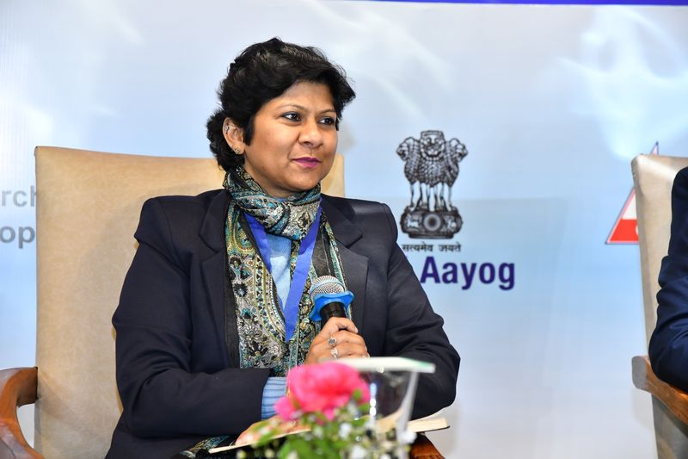
The sectoral needs are going up by leaps and bounds, with the data centers coming up and everybody is requiring 24x7 power supply. How the World Bank group has been supporting? World bank is public while International Finance Corporation is private and then comes the guarantee arm of ours, MIGA, Multilateral Investment Guarantee Agency. We all are working together to promote the renewable energy and green interventions, not only in India, but across the globe. We started with solar parks when the common infrastructure facilities were being done by public sector, but it wasn't being done beyond NTPC and SECI as the central entities.

We were the first ones to take that risk and then we had supported renewable energy sector of Madhya Pradesh. Lot of offshore investments came in, a lot of very good, credit-worthy developers came in, and we also had a very good credit-worthy off-taker side. We had Delhi Metro, as well as the state government's DISCOM. So we had diluted the risk of stand-alone off-taker coming from the distribution companies. This opened up the floodgates for investments in Madhya Pradesh. We have seen that 750MW Riva then replicated in 1500MW, moving on to Ongkareshwar, and now, they are undergoing a lot of similar options, but at different and difficult terrains, Morena, etc.

The key role that the development banks like us play is that we enter in the space when the other commercial investors are not yet ready. We replicated the similar success story with Solar Energy Corporation of India. Many of you know SECI as the auctioneer agency, but they also own a very small portion of the Capex, especially those investments where the normal investments are hard to come by. So, in 2019, Solar, Wind with Battery Storage Project was thought through in Andhra Pradesh in Ramagiri district. That is where we constituted this particular idea around hybridization, picking up from the global examples as well. The AP project, didn't move ahead when it was about to be awarded, but then it was successfully replicated in Chhattisgarh, where we focused more from the renewable energy perspective on the solar insulation-rich states. But Chhattisgarh, Jharkhand, and this belt, which are more coal-dominant states, they are still lagging behind in terms of the installed capacities. There is where a leap of faith was taken together with SECI to pick up a low RE penetration state and try to help them in bringing something which is more stable. So in 2019, batteries were brought in, to do the demand, or the peak shifting. So green electrons being produced during the afternoon hours will be then used to supply to the grid during the evening peak demand period for 3 hours. And this really helped Chhattisgarh because, first of all, during the evening, they were finding it difficult to either get into the bilateral contract, or to buy the power from the market, which was very expensive at Rs 10 but has now come down to Rs 4. This improved the renewable energy penetration in the state and demonstrating to the country that how green power could be successfully shifted towards the evening peak demand to have green power to meet the demand.

On the financial side, we also brought a very small amount of grant to support batteries, which was insufficient to cover the full battery CAPEX, but it brought down the cost of the Capex drastically. Also, we brought together with bank loan, or concession loan from CTF. This entire package sweetened the deal. Environmental, social and technical due diligences were undertaken and so a lot of confidence in technology itself came and it helped SECI to learn, and take it to the next level. We can see the results and a lot of auctions have come out from the SECI side. We did it on the ground, we learned, we knew where the practical problems are, where the supply chain issues are, what we exactly need to do, and it is now reflected in the auctions that they have done. So this is how the World Bank financing comes, and we bring it together. With the stakeholder capacity building, knowledge transfer, global knowledge sharing happens. And then, also to sweeten the deal sometimes as applicable with the concessional financing available in the market.

I would also like to also make as a point about a very specific, peculiar examples that are on the ground. First is the floating solar project with SECI. It was a little bit delayed because of the COVID. Floating solar projects have come up in Madhya Pradesh and we had support on the technical due diligence side to Madhya Pradesh. But another SECI project is coming in Jharkhand which is a very heavily coal-dependent state, very low on RE penetration and we are trying to bring Just Transitions there, by bringing the fisherman community and the livelihood options ingrained as part of the support. So, such things are really helping in looking beyond just ground-mounted solar as opportunity cost of land is high, to go to the water bodies and other areas where we could actually explore more and more gigawatt scale of projects.

My last point is on firm power supply and we are working with Himachal Pradesh, where they have current existing operational hydropower projects, run of the river. Not huge capacities in terms of the storage, but still they have pondage. Storage of 1 to 4 hours is there, equivalent to the batteries that are being deployed. But nobody's looking at those. These are current water batteries available to us. How we can tap into the existing resources, optimal utilization, better utilization, not only of the hydropower resources, but also of the transmission infrastructure. So, we actually have been cooking this idea for the last 3 years. Any new thing takes time. HPPCL took the leap of faith, and issued the tender on 31st of December 2024. It took almost 1 year for us to take a plunge and to keep aligning the bid documents to the requirements of the bidder community. And yesterday, their board has approved the award. So you will hear the news of this particular package being awarded in next few days. In this particular hydropower project half of its capacity, 50MW, will be bundled with non-hydro renewable energy resources and will provide a greener generation curve to meet demand profile of C&I customers. The important point is that we would like to demonstrate that how hydropower can play a very critical role, and how we can utilize our existing resources to support the grid. So, investments in new projects are important, but we also need to rethink the way our current projects are at the moment being driven on the ground.

Question 1: India is facing issues with the tendered few gigawatts of renewable energy, which the DISCOMs are not very keen to buy. At the same time, merchant capacities are not getting the financing. How do you take these two things, both as an energy expert, as well as the rep for World Bank?

Surbhi Goyal: My take is a bit different on this perspective. We always talk about the distribution companies not doing certain things, but we also need to understand that there are reasons beyond a distribution company sometimes to take decision. There are geopolitical reasons, customer interface. The customers, when the distribution companies' linemen go onto the ground, the agitated people can create havoc. Even a single paisa increase on the ground can be impacting negatively the poorest of the poor, or the BPL people specifically. So all these aspects need to be factored in a very, very balanced manner by the distribution companies and their hesitation to sometimes renegotiate, we know that this should not be done. It loosens the confidence of the investments into the sector, but we need to think from their perspective that what are the triggers that are impacting their decision-making, and that is why the regulatory role becomes extremely important. How insulated regulators are from all these interferences become very important. How often they are allowed, even the regulators, to take that decision to increase the tariff. Because now, distribution companies alone cannot absorb everything. We make them as a villain. We always say that distribution companies are always in a red line, but I was so happy to see that in the recent report, by the Ministry of Power, that distribution companies have shown a profit this time collectively. So, sector is moving. The APDRB and other schemes which are there to incentivize distribution companies to have corporate governance measures in place are coming in.

I am digressing a bit, but this is all, again, a big puzzle. We cannot just pick one piece and say that is why they are unable to sign the contracts, because there are strings attached to the distribution companies. Once they start to fall in place, once they become more accountable, once they are a little bit more relatively independent to these constraints, we will see the shift happening. The RPOs, for instance, has played a very critical role. They have allowed distribution companies to go beyond their comfort zone and sign higher-valued, higher-priced contracts. Now, because they also know that their customers have started to demand, their C&I customers are saying, no, I have to export, I need the power to be green, please ensure that I get it. That is how their mindset has also evolved. My problem is that they are not yet looking at the digitization as well. Unless and until they digitize themselves, the rooftop installations, how they should do the power procurement, how should they respond to the customers. This all will become a gray area for them, and they will keep on looking at that marginal impact from the PPS. So this is all a very, very complex and a complicated, segment of the distribution company and they need this help from collectively all of our wisdoms, because they are very ingrained in their day-to-day work. They are unable to even take their heads out of their files to see that what's happening globally. And this is what our experience with working with the distribution companies say. So there is where I think is a bit of a challenge, but yes, coming from the financing perspective on the merchant power plants and all, again, I think the sector is evolving.

Merchant power plants depends on a lot of things are there when the financier is looking at it. Credit worthiness of the off-taker. And how, they are doing their business model, who is behind them, what kind of track record they have, do they have any ESG financing? Or do they intend to do it or access that kind of initiatives or parameters on which they will have to report, because many of the financials themselves are now bound to report back on this ESG reporting. SEBI has come up with a lot of now ESG compliances, greenwashing and all have been now tightened a bit. So this, will gradually start to show the results on the ground, but this is very, very complicated, lot of parameters, again, behind the scenes, and merchant power plants, we cannot generalize. It's very case-specific, very sectoral-specific, very technology-specific. Newer technologies will relatively get lower commercial financing, but stabilized technologies will get higher. Stabilized technologies with standalone solar probably will find difficult off-takers, because nobody is wanting the standalone variable solar. Now they all want firmer power supply, even the green, with storage.

Question 2: Hydro project this is very costly nowadays and risk factors are there. Ecological or the climate condition is dangerous, especially in the Himalayas side and and also Floods. Insurance companies are not prepared. Pumped storage is very costly. 1 MW is costing 8 crore rupees. Who will invest? And the environment, the number of clearances are required, especially the dense forest area, the clearance is required. So, how is the World Bank supporting these investors or developers?
I want to ask that about PV installation on water bodies, like, lakes and ponds, and Government of India is also working on restoring water bodies. So, have you thought of linking both the programs - restoration of water bodies and installation of PV.
Net metering becomes particularly important given the PM rooftop solar scheme. With net metering, there's a trade-off between the benefits for the consumer versus the losses for the DISCOM. And this was an important issue in California, they had a huge contentious debate and they decided not to do net metering. What is your take on that issue? Because for rooftop solar, a solution would be to have storage on-site. But, in India, it's going to be too expensive for the smaller households, to put batteries at their households. So, how do we handle this issue?
Karnataka government has introduced the hybrid - offshore solar with the wind power. India permits 100% FDI in battery manufacturing through automatic route for manufacturing EV batteries and components in India. Is there any plan for his company to set up a plant in India in future?
What is the World Bank's contribution in capacity building and gender inclusiveness? How World Bank is doing this to support more women trainings and skilling.

Surbhi Goyal: Hydropower projects and PSPs - we are looking very actively to support them. For pump storage, we are looking at the closed-loop cycle, so that the environmental impacts are minimized and we are not looking at normal PSPs. But hydropower projects are very expensive.

So there are two parts to it. First is using the existing hydropower projects. We need so much of storage, but we have discounted the existing hydropower projects. To optimize it, we are doing this pilot with Himachal to provide us some more insights. Also it has a seasonal impact and in the winters there will be challenges and hence, it has to be very carefully integrated with the other generation profiles that we are having. So, for instance, somebody spoke about the wind.

Wind comes in the evenings and the mornings, the solar comes during the afternoon. This is what we also observed in Ramagiri's site in Andhra. Hydropower can play a critical role in there. During COVID, all of a sudden, 100 GW drop of load and going up again was only possible with the support from the hydropower project. So, it has that kind of capacity, but needs to be utilized properly. So with that, the hydropower cost could be evened out. Because it provides grid flexibility and grid support services, how we remunerate it becomes important. Not only, if you're looking at it only from the PPA perspective, probably it will not sell, but from the grid services that it could provide, there is where its USP lies, which at the moment, there are very slim regulatory insights.

For the floating solar, as development bankers we are looking at infrastructure and also the entire development aspect, which includes environmental, social and this becomes sometimes a bone of contention for us with the client. So, we are looking at the reservoirs, but we are also looking at the coverage. So we are not going beyond 10% wherever we are investing, so that the impacts on the aquamarine life is minimized. And we are also, with SECI deploying sensors to monitor the quality of the water during the commissioning project to see how much the dissolved oxygen and other pH level, in the water are being impacted, if at all, with the baseline there. We are also working with the government's dam rehabilitation and improvement projects program, to see that how floating solar can be integrated in their rehabilitation and the improvements of the project. So, we are working with the various parts of the government to integrate the floating solar requirements with the requirements of the water and other sectoral things.

On the net metering and gross metering, the opinion is divided. Distribution companies sometimes feel it as a blow to their own revenue stream, because some of the C&I customers would like to go ahead with the rooftop, which means less demand from the distribution companies. But again, we need to think differently here. We all know the science and the law of physics is, if the power is generated and consumed on the spot, the losses are the least. So we need to think from that perspective. The distribution companies also need to think from that perspective, that even if they stall the process, they will have to eventually go towards this acceptance of the fact. Now, how they do it, in terms of the administrative requirements, whether it's net metering and gross metering, it also depends on the ease of the system, how they are able to access the data, how they are able to do energy accounting, whether their meters are sufficient enough, whether their tally and the sophisticated ERP systems are sufficient enough to do the balancing on the ground and to then reflect it in the bill. That is why majority of them are going ahead with the gross metering, so the variability of the solar rooftop can be absorbed by the grid and that is why a lot of the distribution companies started to think about deploying the batteries, smaller battery banks on the distribution transformers or on the poles, to have these kind of issues eased out. This is an evolving space, so the time will tell how this all will pan out, but Delhi distribution companies are doing wonders in it. Tata Power promoting rooftop, BRPL, BYPL, going with rooftop plus batteries. Their local substation has recently commissioned a battery bank, which Grid Controller of India is also looking at, and how they are supporting the distribution sector as a whole, and how to replicate it.

On the capacity building, we have been engaged in green hydrogen for almost 4 years now. We started with analytical activities to first inform our own thinking that how the bank group should involve in this space in India. We realized that loan doesn't make sense for any investment in 2023, when we had seen the mission launched. We had provided a support to government on the policy side. We enumerated that these are the reforms that you need to take, and we will disburse to you. Majority of that was reflected in the green hydrogen mission document, subsequent policy, subsequent bids for green ammonia and the refinery tenders that came in. It was like an incentive for them, that as soon as we meet this, we will get the disbursement. So this is one form of capacity building, or, pushing certain reforms through the sector. The other is the HP project, which required a change of the mindset, how you should look at your existing hydro. Again, this is incentive-based, or result-based program. As soon as they have awarded this tender, we will disburse to them. As soon as they have results coming out of it, that it's able to meet certain requirements of the trade, of the C&I customer through this bundle, we will disburse to them. So this is how capacity building is happening. We haven't invested anything in the asset. But beyond that, every project that we do, we bring capacity building, institutional strengthening through training, through pushing the new ideas, helping them develop DPRs, helping them develop their financial management corporate governance guidelines, having environmental social policy procedures ingrained in their thought process, because they don't acknowledge that environmental social issues, can really impact your commissioning timelines. So, better to address them upfront, include that in the design, and then you execute. So this is how the variety of the ways in which we do capacity building. Our monitoring has a KPI on gender on every project, you pick a project, any of the World Bank globally, the KPI has the gender ingrained.

RAJIB MISHRA, Executive Director (Designate), IRADe
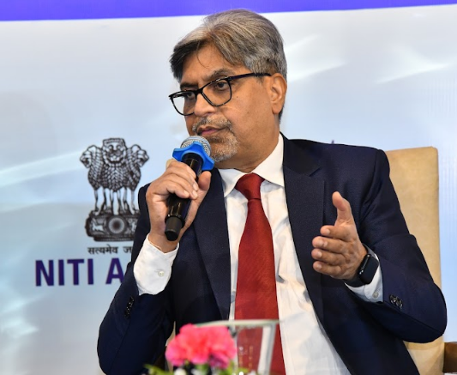
The DAY-AHEAD-MARKET, which was very predominant for 96 time block for the entire day, used to be the dominant market to the extent of around 80% of whatever was being traded was in the day-ahead market. Now, this market is slowly shifting towards one-third each, Real Time Market is now getting dominance. That means you can schedule your power one and a half hours before the schedule. Similarly, the other markets which were not so predominant is also now taking shape.
We have fragmented our market for the obvious reasons. Many markets and products were introduced and experimented with it such that the market will take those products which are acceptable to them. With more RE penetration, we are seeing more of uncertainty and it will be reflected directly how much is being pushed into the market. Our market size is small; depth is not there right now.

The market is developing. The experts are working day in and day out what are the products they should evolve to help RE Market to stabilize in next 5 years. Every year, roughly, we are adding 15 GW of renewable, mostly solar during the day. For next 5 years, what are the supplementary power which has to support it, how much is the storage we require, at what price it should come, and what percentage of it should go to the shorter duration market, how much more should go into the long duration PPAs. All these things are something which can be done scientifically. There are a lot of algorithms which are currently available, and we have to use those tools to find out what percentage should go where. With the development of RE, the market is also evolving and developing, and we will find a very stable, robust market in India in years to come.
On transmission, the national grid is one of the most robust grid in the world, but last mile connection for RE is an issue. On generation, we are meeting our requirements. Storage, of course, is one area that has come up very strongly this year and requires funds, investments and budgetary support. The usage of renewables at the right time of the day becomes crucial and is being addressed, along with the development of the carbon market.

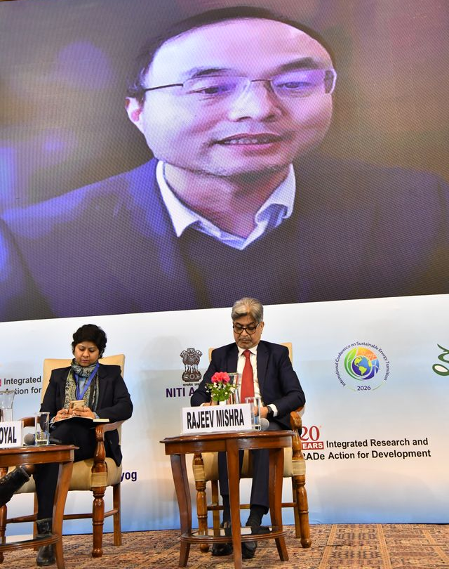

Session 3 – EXPANDING GENERATION

OPENING REMARKS
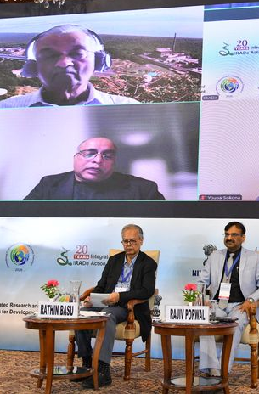
It's a panel which is of extraordinary dimensions. We have Dr. Anil Kakodkar, a figurehead in the Indian atomic energy field and in the nuclear, and not only for India, but the world itself. Dr. Kakodkar, it's a real pleasure to have you on this panel today. We have Dr. Deb Chattopadhyay from World Bank, an energy specialist with a doctorate in power systems. We have Mr. Porwal, and it's great to have you with us.

We know that the country is increasing power generation, by leaps and bounds, and more so in the renewable field. That brings not only the happiness, but also its problems associated with huge amount of renewables, which is not predictable. So let us hear it from our esteemed panel experts.

DEB CHATTOPADHYAY, Senior Energy Specialist, World Bank
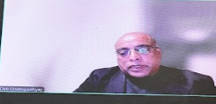
Thank you and good afternoon, all of you.
I worked for the World Bank for the last 12 years, and I'll try to summarize our coal transition activities in that space, from the perspective of not just the World Bank, but also other multilateral development banks, like Asian Development Bank, the European Bank and African Development Bank.

Before this energy transition became a household word, there's been a lot of enthusiasm around entry of renewables. However, around 2016, there are reports that claimed that half of the global coal capacity, which is about 2,000 GW at the time was already uneconomic compared to wind and solar. In 2017, again, there was a claim that India has got 3,000 GW of wind potential, of which 2,000 GW is too good to be left alone. So, there are no justifications for that, and they missed the point that we can't compare simply the cheapest solar option that took place in Middle East and say that coal should go out and renewable should come in.
At the margin, if you have a fossil fuel damage system, solar comes in, it does save the operating cost of coal, but the moment you actually go deep into that, in terms of the penetration, cost will actually increase to 7 or 8 rupees, and then towards the end, it will actually go to 20 or 30 rupees per unit. So, there are energy transition mechanism, which was promoted by ADB, which looked at electricity purely as a commodity, and one-for-one replacement with renewable at the core of it.

The World Bank started Accelerating Coal Transition Program had issues and flaws, in terms of accelerating the retirement of coal. Then we looked at some of the developed country transitions, particularly in the UK, followed by U.S. and also in Australia and there were troubles. However, in South Australia, they shut down all the coal plants very rapidly and there were 3 great failures, which was unheard of in Australia over the past 50 years before that. But, in terms of the program design over the last few years, especially with our accelerating program, we focused on is not so much a sort of a rapid shut down of coal but pick up coal-generating units in a power station, which are particularly old, inefficient. And if we could convert that into synchronous condenser and use the space in the power plant with battery storage, that seemed to give a good balance, and we are actually doing a fairly large program in South Africa at the moment. And South Africa was actually going through very serious load shedding, daily 6 to 8 hours. But this coal transition program still went ahead. So, we have about $6-8 billion program, 55-60,000 crore Rupees all over the world. But out of that, about $2 billion in South Africa is probably our brightest example. We do hope that we'll see lots of battery storage put up on these coal sites. But again, the entire plant is not being retired.

We also did quite a bit of dispatch analysis, and found out exactly where the flexibility is needed. If we could eliminate some of the older plants, which often need to run 60% - 70% minimum loading because of their age, and also among the slowest plants, then you open up some space. If you then plug in some battery to balance the loading on the remaining core units, which are both faster and more efficient, and probably cheaper also in many cases then we have a happy coexistence of coal and renewables. Plus, if you put in some synchronous condenser, that is very helpful in terms of voltage control, making sure that the voltage instability does not creep into the system, which is what caused the South Australian systems to fail. So in terms of the overall program design, this has actually taken off in a big way in the US. So, there are at least 10 GW of coal plant repurposing that has taken place. A lot of them are very heavy on battery storage only, but there are others which are putting up solar panel in the available space.

We have in South Africa, for example, some of the plant sites are 2,000 acres, massive plants where we are putting up 250, 300 MW of solar alone and plenty of battery years, and also lots of synchronous condenser are being put also in the Australian system, in the European system. So, in terms of, managing the transition, if we are sensible about which units, and take a system-wide view, identify with some surgical precision, through dispatch analysis, exactly where flexibility is needed, make sure that the good parts of the units, even if they're expensive, inefficient, when they're being retired, their services are actually retained in terms of the ancillary services, so the generation is not really an issue, but the stability and especially the voltage and angular stability, need to be taken into account. So we are probably on the right path now, after lots of experimentation over last 6, 7 years to find a design that should work. We are also going into Vietnam, Indonesia, a couple of East European countries with that program. And I hope that at some point, we'll actually also have a chance to actually work in India on that project.

RATHIN BASU, Chairman & Independent Director, GE Vernova T&D India

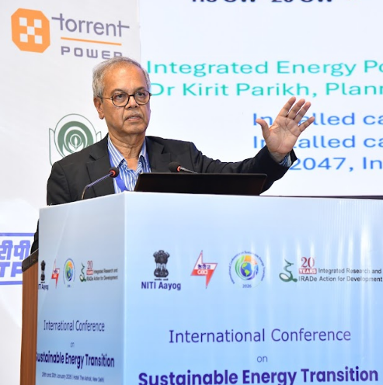
We first look at the roadmap since our independence till 2047. Today, in January 2026, we are having a grid, which is of the size of 514 GW while during Independence, it was 1.4. So it's a 400 multiplier over the last 78 years. And going towards Viksit Bharat, we are aiming for 2044 GW, so that is 4 times of what we have today.

It's a tremendous transition that we are going to go through. The more critical part is the renewable energy as a percentage in terms of capacity, as well as in terms of energy. So, in terms of capacity, today we are already at 48%, with the energy contribution to the consumers, 22%.
In just 6 years' time, we will be at 66% of installed capacity for renewables, and the energy contribution jumps to 33%. And then, 2047, the target predictions are at 85% renewable generation, producing 60% of energy. So that's the landscape.
How do we plan our grid stability generation?

20 years ago, the Planning Commission document was produced in 2006, gave a plan for next 25 years, till 2032. India had 138 GW and the plan was that India would go towards 770 GW by 2032. The current forecast that we see today is 961. So, the vision was in the right direction but what changed is the composition. So, from 138 GW, you were supposed to add 270 GW of coal, 80 GW of gas. The interesting point is renewable. At that time, the thinking was it would be only 96 GW.

The biggest change is for the gas because gas is extremely expensive for Indian electricity market. So instead of 80, it's down to 9. The positive part of the story is that huge amount of renewables coming up from 96 towards 571 GW, which leads to the breakup of 961 GW. So, the energy transition over the last 20 years for a plan of 2032 has been massive.

India has achieved the generation change, as well as the stability of green extremely successfully. The baseload, by 2032 is supposed to be 411 GW, supported by RE, 633 GW. PSP to come up 36 GW, but there are efforts to make it bigger. And BESS is supposed to be 47 GW, but again the efforts are in the country to make it even bigger. NTPC is the biggest player in the thermal circuit, it's a single biggest factor for grid stability because of the base load size. The largest chunk comes from them. So this is about grid.

In the grid side, both in generation as well as in transmission grid, India has been really making in India, before the “Make in India” became a famous slogan. And, it has attracted all the best technologies of the world. And thanks to Power Grid and its vision since early 90s, you have the best of best technologies concept implemented, executed, most of them absolutely on time. So, result is that in 1991, India had 5 different electrical grids and then in December 31st, 2013, India became the synchronous country. And at that time, the grid size was 230 GW. Even at that time, it was the largest single frequency AC grid of the world, and even today. It's not China, it's not US. And you need to be proud of that. Hats off to PowerGrid and all other partners of PowerGrid.

The other point is the inter-regional power flow. We need inter-regional power flow to avoid congestion and for long-distance power flow. Both the things are extremely important for the forthcoming Viksit Bharat journey, which is just 21 years ahead. The thumb rule is 20%. The European Union guideline for any electrical region on a single frequency that the region should have at least 15% of the capacity as inter-regional transfer capacity to avoid a catastrophy. Going forward to Viksit Bharat and where we are going to reach by 2047, the challenge is managing the huge amount of renewable energy that is going to go into the grid. NTPC is now 87 GW as on January 26th and their published plan for 2032 is 130. The inter-regional capacity is a crucial factor as we go towards managing grid transitions.

It's important to understand what happened in Spain on 28th April when Spanish grid was a 129 GW grid, 66% came from renewable, 75% of Spanish Electricity comes from green, clean energy. But they had only 3% inter-regional transfer capability through the France corridor, which is very, very low. The battery storage was only 57 MW. Spain has been running on renewable fairly large numbers. So, this is a scenario which should be happening somewhere between 2035 and 2047 in India, in terms of the percentage numbers. What we need to learn from the Spanish experience is, you need baseload available at any instant of time. Unfortunately, on that fatal day, there was an unscheduled shutdown of 13 GHz of generation, so there was no overall supervisory control to permit this shutdown. There were also several protection failures and they could not protect the grid anymore. So there was total blackout. I have some horror stories of some of my Spanish friends who suffered so badly that day that they recommended that you should always have a pocket radio and a battery charger, just to stay connected with your family. Because children were at school, and they didn't know how to reach to them, so that was a catastrophic story. So, it's a good lesson from the Spanish grid. So, for us, when we are going towards this huge energy transition, it requires a high level of grid management experience.

Tomorrow's grid needs to be managed with baseload and flexible resources. NTPC, with its mixed fleet of thermal, hydro, PSPs, and solar have to play a big role in the stability of the grid. The next phase, nuclear, we have huge potential for nuclear, and NTPC-NPCL joint venture is a huge positive development. And private investors, because of the Shanti Act, is another huge opportunity for us, because nuclear today is only 9 GW and expected to be around 22 GW by 2032 and the country's target is to reach 100 GW. At the same time, we need the BESS so that the battery storage plays a role to support renewables, and same for PSP. PSP needs 6-7 years' time to come up, so it's not going to be a solution for tomorrow. For BESS, it's again an issue of battery localization. We still have to wait for 3 years. Until then, our trade balance with China will go up from $100 billion.

The final point is energy security. As a country, we need to be extremely sensitive towards energy security and baseload, which is coupled. Energy security comes from coal. I believe that India can do a lot to use its coal, to make it green by using CCUS. CCUS can help NTPC and Coal India to ensure that our coal becomes clean and opportunities are there for both public sector and the private sector like L&T, Adanis, Tatas where NTPC could be the catalyst influencer, they have deep pockets, they could invest, and they could stimulate the country. On the nuclear side, the question is can we use our thorium reserve, which can produce 500 GW of nuclear power each year. And to do so, we need to have a focus on nuclear so that we can go towards the 100 GW target from the present 9 GW.

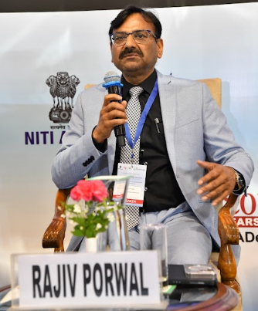
RAJIV PORWAL, Director, Grid Controller of India Limited

We are the system operator of the country. Some of the regions and states in India are meeting more than 100% of electricity at some point of time from the renewables only. So it is a similar situation, just like the other countries and we are also a part of a big interconnect. India has a big grid and, there are conditions, then, when we have instantaneously touched the 40% of VRE only, say, solar plus wind, penetration is going more than 40% in this country itself on certain times. So it still has started to become quite challenging.

As far as generation portfolio is concerned, we have already talked that 100 GW of nuclear is targeted by 2047. Similarly, thermal is also going to be around 290 GW. We are also building new thermal as well. But only important point is that in today's grid, we are approximately needing 80 GW of duck curve during the daytime and this will keep on increasing as we will keep on integrating more and more solar and wind. We need more and more flexibility from our baseload plants. Presently, it is as per our regulation, it is 55%. CEA has also come out with the regulation that we need to go to 40%. Some of the developed countries, whether it is Europe, USA, Australia, they are going down to much lower levels, so we also need to plan in that direction. We have to plan from all the directions, apart from flexibility, we have also to go to from the load side also.

Another important point is that load which is coming in future is also very fluctuating. We will be coming with a lot of EVs and data centers, green hydrogen, these loads are in the inverter-based resources have their own type of challenges, which we are facing from the inverter-based generation. So, from both sides, we will have these, different type of challenges. One is that variability and so we need flexibility. From another side, challenges would be technical. When these large number of inverters are there, they will interact with each other and there are oscillations in Indian grid when we have large quantum of these IBR-based resources concentrated in very few pockets. In Rajasthan, we have already gone with around 35 GW of VRE, that is solar and wind, both at interstate and intrastate level. Also in Khavda area, we are going ahead with the 40 GW, presently around 10 GW is already commissioned and another 30 GW will be commissioned by the next few years, so we'll be reaching around 40 GW within a small area. So, from one side, we need flexibility, faster ramp rates from our conventional resources, whether they are thermal power plant or nuclear. But from the other side, from the inverter based resources side we have recently come out with a draft consultation paper on the grid-forming inverter, with battery storage, some grid-forming inverters, these are controls and these controls are quite faster. So we have also to look for a paradigm change, whether it is for the source circuit current, whether it is for the inertia, whether these new type of resources can provide those services as well.

Our grid has become larger, and we have come out with our simulation capability at all the load dispatch center, or the utilities also has increased manifold. But that also need to increase faster at much faster rate. We need to migrate towards or graduate towards the EMT-based simulations, and more and more technical solutions has to come. So, from the technology side, we need to invest a lot. Government has committed that we will bring in 500 GW by 2030. The technology is evolving, so the rates will go down. But as far as the fossil fuels resources are concerned, those rates are going up. So, if they are going up, these rates are going down, so definitely economics will also suggest moving towards the renewable, but we have to get the essential services from them.

We have to also look from the distribution side, from demand side, how these demand resources can help. Presently in our country, that type of infrastructure is still missing. First thing will be to find out that what is the benchmarking base, baseloading them, what their profile is, that profile somebody has to certify. Then. how we can measure that they have actually performed. So these two things are important before we venture towards that direction.
Secondly, there are schemes between states and interstate systems. If we want to manage a very large, complex system, we have to demarcate in small segments, and people have to be responsible for those areas. In other countries, they are called as balancing areas. We have also come out with another paper where we have done, for the automatic generation control for the renewable plant, for solar plants as well as for the battery energy storage systems. We are also going ahead with taking different intrastate conventional plants in our fold, so that they can participate in interstate ancillary services, so they will get some revenue also, as well as some experience before they can participate in intrastate ancillary services. Different regulators are working towards interested regulations for ancillary services, but we have created a condition wherein these states can also participate in interstate ancillary services, and that will give them a lot of experience, how they operate, how the money comes. These are also actions which need to be initiated wholeheartedly from the state side, from all stakeholders in the country towards how we can bring flexibility. We can utilize flexibility.

Any ancillary service is a risk mitigation scenario, it is a reserve. Reserve means that it may not be utilized. But, if they are in the market, if they feel that ancillary services market is giving them good revenue, they will definitely come. If the energy market is giving them good revenue, they should go over there. They should not be forced that if they are given to system operator, they may not be very effectively utilized. So, the remedy is that there should be a market for ancillary services, people should come out willingly. Flexibility is extremely important from all of our conventional resources; second thing is that these essential liability services have to come from the renewals; third point is that we have to understand the load side which can also provide flexibility; fourth point is that we need to focus more and more on technical solutions, technical input from our academic institutions, our research organization. This is the not only for India but for the world.

ANIL KAKODKAR, ex-chairman, Atomic Energy Commission of India

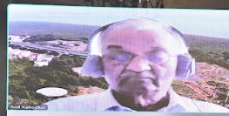
In the clean energy transition, going forward, many of the demands that are currently met by a non-power sector would have to be met by power sector. For example, all hydrogen generation, will require huge energy, it will essentially, as a first step, require electricity augmentation. Same thing is happening in the context of transport and many other aspects of industry. So, this proportion of power vis-a-vis total energy that the country would require, it would increase in a very galloping fashion. And so, the first point that I would like to make is the growth in power sector should take this into account to open up a new kind of horizon where we need to be ready.

As the share of renewable to baseload increases, the tariff would go up, if that baseload is not clean. You need a good combination of both renewable energy and base load. But you also want to move towards clean energy transition and so that baseload has to be clean. And this is a factor many times we kind of overlook, and this is where the importance of nuclear comes in, and of course, I'm quite pleased that countries now have realized the importance of nuclear. We have this Clean Nuclear Energy Mission of 100 GW. I want to address the problem from the end destination perspective.

Viksit Bharat means the average Indian should be able to enjoy quality of life, or their HDI in India should be comparable with advanced countries in the world. From the correlations, if you look at the minimum energy that is required to be part of those developed countries and multiply that with the India stabilized population, that comes to 28,000 terawatt hours per year. Now, the total renewable energy that India can have on Indian landmass, Hydro, Solar, wind, biomass, all put together, the total renewable energy potential in India, would be maximum around 8,000 terawatt hours. So there's a whopping gap. This 8,000 terawatt hour per year is good enough, for meeting the current consumption of total energy. But, when it comes to Viksit Bharat, there is a big gap and that has to necessarily come either from nuclear or fossil plus CCUS. It will also add to the cost of energy, but it is inevitable and also within the feasible domain.

We all should be reconciled to very heavy participation of nuclear energy. What is our energy resource position? Today, worldwide nuclear energy capacity is of the order of 350 GW and maybe next 10-20 years, it will go up. Some countries have said that they will triple. So, on an average, even if it goes up to 2 times, it would become something like 600 GW. Our 100 gigawatt Nuclear Energy Mission would require, at that time, 16% of the total uranium, which is the main fuel for nuclear energy. And, if you look at it from the current production of uranium, it may even become 25% to support 100 GW. For the larger energy needs of the world, use of nuclear fuel is not sustainable. And so I think we need to recognize that we need to go to closed field cycle, which is also necessary from point of view of the waste management concern that the waste remaining radioactive for a very long time. And it is in that context that vast thorium resources that we have in India, because you can't think of thorium without recycle.

World has avoided recycle for political security reasons. But, if you resort to recycle, one may as well adopt thorium, where India is the world's largest resource, and we can meet our energy requirements, both India's, and also maybe a significant contribution to global energy requirements. We should also recognize that once you get into thorium, a lot of security issues and concerns about recycle would actually go away. I have been championing use of thorium and the PHWR reactor that we are adopting are robust well proven technology, having demonstrated global scale performance and they will compete economically with any other source, they have been doing so, and they will continue to do so.

One thing that we need to recognize as that as we accelerate the growth of nuclear capacity, we should also develop on deployment of thorium as a fuel. Now, how do you do that? We have this three-stage program, that was visualized earlier when we couldn't get anything from outside, we had to depend on uranium available only within Indian landmass. And so, the first stage we were talking about was only 10,000 MW. Now that we are able to import uranium and we are now talking about 100 GW, where instead of 10 GW, so 10 times larger first stage, meaning reactors running on uranium, I believe that even for this 100 GW, getting uranium towards the later phase will become a challenge. On the other hand, if you start deploying a combination of low enriched uranium, mix it with thorium, then, you can show that there is economic advantage, there is a safety advantage, there is a proliferation resistance, and most importantly, you can produce enough uranium-233, because this is what we're planning to do in fast reactors. I believe that the uranium demand will become critical much earlier than our being ready for large-scale thorium capacities leveraging fast reactors. So, we should leverage the existing PHWRs and use this fuel and be ready to go to third stage, the Thorium-Uranium-230 stage through this means, and the rest of it remains the same. These recycled technologies for thorium, they remain the same. The reactors for third stage remain the same. Only thing is, we will be able to regain some lost ground and contribute to capacity in tune with the requirements as they arise. There is a question of deployment rate. And, I hope with the Shanti bill, and with many players, NTPC particularly, but we hope many other private players and also public sector units will get in. Then we'll be addressing this problem of deficit in terms of our deployment capability. And, if that happens, I think we should be able to meet both development targets as well as the clean energy ambitions.

I would like to touch upon flexible operation of power systems. This is very important and now, the PHWRs as they are, because their cladding is collapsible cladding, whereas all reactors which have high burnup, the PWRs, BWRs, and even thorium with 7-8 times larger burn-up, the clad has to be much thicker, freestanding clad as against collapsible clad. And the fuel for such reactors can indeed be designed to facilitate flexible operations, at least to some extent. And France is doing that even today. So I think that's another advantage that we need to bring in.

The last point is with respect to technologies, apart from PHWR, because there are niche areas emerging. Either for hydrogen production, or for retiring coal plant capacity, or coal plant sites, there are important brownfield opportunities for new nuclear plants. The small-medium reactors, or the advanced reactors, we should devote our energy towards fulfilling such niche areas, while PHWR remains the mainstay. And if you do that, we'll be better positioned to reach the high capacity requirements, not only till 2047, but even beyond.

Question 1: My name is Diljit Singh. I have worked for a variety of civil society organizations on the power sector. Mr. Rajiv Porwal mentioned inverter-based resources and the problems they cause. Stability requires inertia and they don't have the ability to ride through a fault which needs to be fixed. The other issue is harmonics, which can be corrected and compensated for. Can you give me a very rough idea of how much these corrective measures will add to the cost of solar.

Rajiv Porwal: As far as harmonics is concerned, it is very minimal, very small quantum filters have to be put in the plant. As far as LVRT is concerned, presently this is a mandate or regulation is already there. Their checking at the time of commissioning or during operations may not be that elaborate at state level, as at interstate level which is very elaborate. As far as reactive power capability is there, they have to provide 30% of reactive power, so whether they can provide or they have to install some reactive power compensation devices, say SVG, that is also not very costly. Maybe, 2% cost might be increasing. As far as present cost of grid-forming inverters may be there, they may be around 5-10% costlier than grid-following inverter. So controls may not be that much costlier, but because this is a new technology in this area where people have gained the technical know-how. But, with more and more competition, cost of that technology will also go down.

Question 2: Regarding impact of energy transition, nuclear power slowed due to new laws. Is this before or after the Shanti Bill?

Rathin Basu: If you recall, this original nuclear plan in 2006 document, we were supposed to reach 64 GW by 2032. Why it slowed down in between? One of the major factors was the Fukushima nuclear accident in Japan and because of that there was a nuclear liability clause passed in the Parliament that scared all international vendors. So therefore, the whole program got delayed. We couldn't move at the speed that we thought in 2006.
After Shanti Act, there is a partial amendment on that, and then private investors are welcome. So, I would imagine the risk is not that great, but still we need to navigate because the fuel side is still not fully solved. The ideal solution for India, from security of fuel, is we master the thorium cycle, but that depends on the fast breeder reactor, but that program is delayed by 10 years, because of complex technology involved.

Questions 3: CCUS is a penalty, it's a cost, there is no profit for it, maybe very small for oil recovery, but mostly it is cost. So, who is going to bear the cost? Because no private entity is going to take that initiative if there is no benefit on it. So, how do we see CCUS as a solution when there is no profit?
Rajiv Porwal: CCUS is a technology and a product which has to be sold to utilities and utilities have to include this in their CAPEX and at the end of the day, consumers have to bear the cost. But we have to optimize on that because it makes our coal clean. Today, our number on CO2 emissions looks big, and we still are building coal plants and at a national level, we are facing the criticism. So, as a country, as a priority, we should cross this CCUS hurdle, and invest to make it cheap, and then the market will be beyond India and this could create a huge export opportunity for India. So, CCS is not a cost per se. It's a technology breakthrough that we need to cross, and India gives the scale and the scale is enormous.

Question 4: Anil sir mentioned about thorium. India has the largest thorium reserves in the world in Kerala, Tamil, and Odisa, nearly 8 lakh tons, or more. My question is, could thorium realistically replace uranium in the future nuclear power generation? Reason being, because uranium is mostly used, and thorium is still under experiment and R&D stage.
Anil Kakodkar: There is this fundamental difference between uranium and thorium, as far as nuclear energy production is concerned. Uranium has a small component. There are two isotopes, one is a minor isotope which is 7 parts in a thousand, is fissionable. So, when you talk about nuclear reactors of present generation this fission creates nuclear energy. Going forward, if the nuclear energy capacity goes beyond a particular level, then you will have to recycle - you will have to start making use of whatever uranium-238 which is in the reactor and that will get converted to another fissile species. In a reactor, you consume fuel, but you also produce a fuel. Thermal reactor, you produce less fuel compared to what you consume, but you consume significant or you produce significant quantity, and if you go through that recycle mode, then you can make energy out of uranium-238. Thorium does not have any fissile component and that's why you cannot start a reactor with thorium alone. But if you have large enough reactor capacity, you can convert thorium to uranium-233, which is fissile material. You can use thorium in the same way as uranium.
In the three-stage program the objective is to enlarge capacity, because total capacity that we could support, only 10 GW in the first stage. Today, because we are able to import uranium, we are talking about 100 GW. Compared to the time when three-stage program was visualized, today we can have much larger capacity in PHWR itself and so you can irradiate thorium in PHWR itself, and start producing uranium-233. We have two options. The fast reactors, whenever they are ready, use them to produce uranium-233, which is a very sound option, but there is a time issue. And also, you can use the augmented PHWR capacity, which hopefully will happen to produce more uranium-233. So, in that sense, they are not exactly identical. But PHWRs do offer us an opportunity to make that transition.

Question 5: The grid is playing a very important role. I would like to know how much we are concerned about the cybersecurity issues. It's so important for energy, but the cybersecurity complicates everything now. So, are we taking enough measures as a controller of the grid?
Rajiv Porwal: Cybersecurity is extremely important. Government is also putting a lot of impetus on the cybersecurity front. As Grid India, we are responsible, we are also the coordinator for entire load dispatch center. But this is the entire gamut, because now everything is interconnected, whether it's a distribution company, whether it's a state, whether it's transmission, generation, or renewable generation, or, in coming future, when we are talking about getting the data from the rooftop solar, or smart meters. Everything gets interconnected. Therefore, cybersecurity is becoming much more important at each level, whether when we collect data from, say, individual household, from the rooftop solar, there has to be some, local concentrator where also cybersecurity needs to be taken care of and then, when it goes to a distribution control center. So, a huge lot of work is already being there. There is a guideline from the Central Electricity Authority also on that, and people are following that but we need to continue doing much more. People are much ahead in cyber field, and there is huge area of improvement and technical investment, technical expertise where we have to keep on improving.

Question 6: In the 100 GW target for Viksit Bharat 2047, is there any number allocated to SMR as a technology?
Anil Kakodkar: If you talk about small reactors SMRs, and keep the modularity aside for the time being, then India has the maximum experience on small reactors, because we are the only country which run the smallest commercially viable reactor 220MW PHWRs.
There lies an opportunity and there is a current discussion between industry for their captive clean power needs and that discussion is currently on. Also, most of the SMRs have not matured yet, they have not been deployed, although there are 70-80 designs of SMRs, there are only a few which have been actually built.
Firstly, SMRs will become reality only if they get large orders and order book of the supplier / producer is in double-digit numbers, SMRs are not likely to be viable. So there is an initial barrier. Initial units will be more expensive in terms of tariff, and question is, who will bear that cost?
The second part is, wherever there are niche areas, and you deploy SMR for taking advantage of that opportunity, but as a kind of means of large capacity addition, I don't think SMR can play a big role. If 100 GW is coming out of 100MW units, I need 1000 units. Whatever happened in Fukushima and earlier in Chernobyl had impact on us - so any event in any reactor will have a crippling effect on the program, not only in the country, but worldwide. SMRs, if we are talking of 10-tenth capacity, then core damage frequency or chance of an accident has to be 10 times lower. 90% of the SMR designs will get out based on these criteria. It has some role but it is going to take time. So, the hype being created around SMRs is unreal.

Session 4 – EXPANDING GENERATION
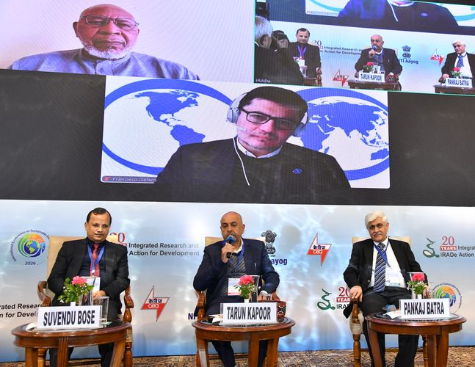

OPENING REMARKS
While the whole world is looking towards moving into renewables and the usage of fossil fuels has to be reduced gradually in India, we are taking this as a challenge because we import huge quantities of fossil fuels. On coal, while we have good resources and good production, but there is a limit to what we can do with coal. For oil, we have to import almost 90% of our requirement.
For energy transition in a sustainable way, renewable energy through the grid is one answer, but there are a lot of applications where we have to remain off-grid. There are some industrial applications also where probably electricity may not be the only answer. Say, cement industry or steel industry where their requirements are a little different and we have to look at certain other fuels like green hydrogen, even biofuels and there might be some innovations in the future.
Nuclear hold big promises and we keep hearing about SMR and the costs are also coming down. Moreover, we will be able to use thorium and other resources which are available in the country. So that's why now we are very optimistic about nuclear energy playing a very major role in the Indian power system. Recently, we've had a new act where private sector is being facilitated to come in nuclear power generation in a big way. But, the real deployment of nuclear power is still about 7 to 10 years away, and then it might take off in a very big way and maybe a big answer for us.
In the meantime, we've had big success as far as renewables are concerned. Solar with battery storage, and a combination with wind, is able to provide round-the-clock power also. The price has also come down. While the new thermal plants are offering power, if you include both variable and the fixed cost, then it is more than Rs 6, but with battery storage or pump storage, and with the combination of wind and solar, in tenders, we are getting round-the-clock power for Rs 4.5 – Rs 5 with renewables. So, this seems to the best and more sustainable solution for us. But the challenge comes in grid management. We have to expand our grids, because certain areas have big, resources, but the loads are in other areas. So the whole grid, the whole configuration is gradually having to be changed which requires huge investments. Grid stability is a challenge, although solutions are available and we have to be confident about we have to do it so as to not falter.
We have to put storage wherever solar or wind has already been installed, so that whatever capacities and transmission we've got, they get optimally utilized, because right now they're not fully utilized. So, moving forward, we have a very clear roadmap, and we are quite sure that we will be able to transition very fast and in a sustainable way. We have good companies, we have good technical manpower, and also we are into R&D so that latest technologies are also available in India.

YOUBA SOKONA, Former Vice-Chair, Intergovernmental Panel on Climate Change

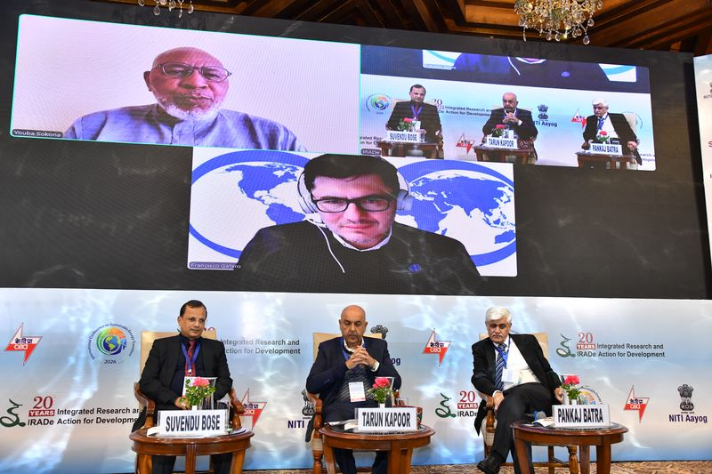
I will highlight some elements in the Aligning Development and Climate Goals in the Africa Energy System and a context-specific pathway for clean energy transition in the African context. It is not just energy transition in the context of Africa is not just an energy issue. It is about how society produces wealth, manages risk, and exercises power. Africa's energy transitions are development imperative and must be judged by their ability to deliver livelihoods, equity, and structural transformation.
There are dual challenges the African continent is confronting, that is lack of electricity and electricity access along with the urgent development needs and achieving the climate goals. Most of the time, there is a tendency to reduce to a single entity in Africa and then ignore local context, resources, and priorities. And there is no one-size-fits-all energy pathway for the continent, because each country must navigate its own unique solution space. And there is a need of providing evidence-based, country-specific recommendations for energy transition.
Africa is not a monolithic and the context matters. The energy landscape is highly fragmented in the continent and energy transition starts from very different baseline and costs of clean energy, investment risk, and institutional strength varies widely. Low electricity access often faces higher clean energy costs. Green fuel availability does not determine electrification success. Strong institution lowers the cost of capital. There is a number of African countries that have high natural gas reserves, some have high fossil fuel, and some do not have any of those.
We can identify broadly four clusters of countries in African context, archetypal countries.
- One is represented by Ethiopia, and that is already on the green path and needs better governance. They have adopted green pathway via hydro. One of the largest dams in Africa is functional in Ethiopia, and then they have also potential solar developing. And then the key characteristics that, in the context of Ethiopia, is a low-cost renewable, and then high hydro share. Kenya is similar but with a focus on thermal and solar.
- The second is South Africa that has managed a just transition for coal workers, because South Africa has a strong institution, a clear understanding of energy issues, and clear policies. South Africa has the legacy of fossil fuel system and social equity focus is very important.
- Burkina Faso needs decentralized solution for rural access. They have different pathway in order to move to energy transition. Their approach should be modular, decentralized access, because there is no fossil fuel-based resources, but there is a huge potential of renewable, particularly the solar. The low level of electrification implies the high cost of power.
- Mozambique, like Senegal, faces biggest dilemma, how to go from renewables, or from fossil fuel, and then how to navigate between the two different elements. Mozambique is one of the few African countries that discovered oil and gas, like Senegal, Mozambique, Tanzania, Mauritania, etc. In terms of gas renewable, they are in a crossroad and a critical dilemma in those countries. Good investment in oil and gas imply export-oriented but the response in Europe is a structural problem for Europeans importing gas, particularly from Africa. And then the country may face massively invest on gas.
Renewable must be the long-term foundation of African energy system to reach development and climate goals. But the pathways to get there are diverse across the African continent. One has to keep in mind some key issues in the continent - lack of understanding of country-specific starting point, largely detached from achieving African development goals, and a lack of evidence on which energy and climate mitigation and adaptation pathway are best able to drive development agenda in the continent.
There is also emerging evidence of solar in Africa. Based on the statistics of export of China solar panel in Africa, for more than two decades, solar has helped improve lives across Africa, from powering schools, hospitals, pay-as-you-go in homes, street lights, water pumping, mini-grid, and more. As up to August 2025, there has been a major pickup in solar panel import into Africa over the previous 12 months. After solar import from China rose 60% in 12 months, then the rise happened across Africa when 20 countries set a new record for import of solar panels in 12 months in 2025. Solar panel import will provide a lot of electricity to avoid fossil fuel-based electricity generation.
The African Institute for Sustainable Energy and System Analysis that has been conceived to respond to some of those critical element like the continent's need for strong institution in Africa to plan, implement, govern energy and climate pathways for development. This has been largely done by the multilateral and bilateral organization. There is a need also for clear African ownership to translate plans to short-term and long-term impact, and the needs for evidence-based African-led, country-specific development pathways.
We defined five processes of research areas, how to deal with these issue.
- The first cluster of activity is a clean energy pathway for development.
- The second cluster is effective implementation approaches.
- The third is policy and governance.
- Fourth is access to affordable finance and technology.
- Fifth is building institutions and skills in Africa,
From the African reality, on energy poverty, skill deficit, energy infrastructure deficit, this are all very well known, well documented. While critically responding to renewals, we played a fundamental and critical role in defining a three-pillar approach of context-specific energy climate and development knowledge building, skill development and to provide a number of solutions on climate development and energy nexus.
So, to sum up,
- Africa's energy future must be clean, equitable, and context-specific.
- National ownership is non-negotiable for success.
- International support should be enabling.
- Urgent action is needed in finance, research, and governance.
Aligning development and climate goals is not a contradiction in the African context, it is an opportunity for transformative African-led growth. Thank you.

SUVENDU BOSE, Senior Advisor to Ministry of Energy, UAE

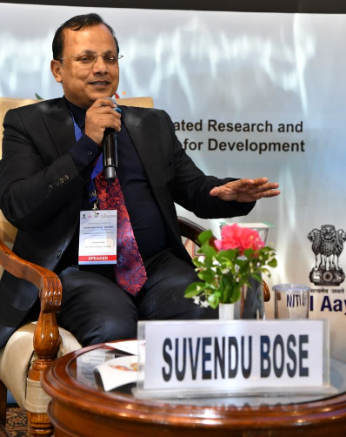
When we do the energy strategy in UAE, the first question we ask ourselves is can we get away with the non-renewable. Two data points for us - Oil-GDP multiplier was 0.24 whereas the clean ICT-based economy is 1.8. So definitely, as a whole economy, we have to do diversification to non-oil economy where the bottom line is the energy cost. If we continue on gas-based vis-à-vis the renewable-based, there is a difference of 10 fils of the tariff by 2030. So, if we don’t go renewable, there is huge economic loss, we lose country competitiveness, lower investor attraction, and so we have to adopt renewables. With the sunshine in the UAE, the intergration to solar was considered and we found three challenges on the integration.
One is technical, in terms of intermittency, forecasting errors, inertia, fluctuations, etc. The second, is a commercial issue on integration. I work in a very small grid, 33 gigawatt peak. So, within 2 years, I can come to the entire renewable, 100 GW renewable, and we can do the energy transition. But, my existing investment in the gas, contracts, pipelines, how do we taper off the existing one, and that increase the renewables? Commercial utilization based on that, because the bankability and financial collapse has to be avoided. So, that's the integration issue, which is the pace of change, transition. Third is financial. Every time we are concerned about the cost of generation. India is a big grid and even when we are doing 150 GW, the percentage energy-wise is not much. However, in the UAE, we are fortunate to handle a smaller grid, winter load is almost 14 GW and we already went ahead with the nuclear quite early. From 2020 till now, we already put 5.6 GW nuclear in a 32 GW grid peak. Out of 14 GW, 5.6 comes from nuclear, 7.5 comes from solar. So, we are actually facing a challenge when the large-scale renewable integrations of the bigger grids might have, we are already seeing this.
If I replace 1 MW of gas or coal, I need 5 MW of solar, but I also need 5 MW of transmission. The sensitivity of the cost of generation is 0.3 million per megawatt, but sensitivity of the transmission is 1 million per megawatt. In the transition, 75% of the energy requires time shift. So, minimum investment in the transition case, instead of 2 million in the thermal case, goes to almost 11 million.
If I put the transmission on this 5MW transmission, but itself is 20% loaded, the actual cost of transmission delivered is much higher, because each transmission line is partially utilized compared to thermal. And then, we have to consider 16 hours of charge during the non-solar hours, along with the reactive compensation and the cost of grid is much higher. We did a check country-by-country where renewables have taken over, we did not find a case where there were cheaper sources of generation but the tariff is going up. So, we could not find a match and we figured that it was due to the cost of the grid. That's the biggest problem that we needed to resolve.
In 2025 January, we finally tendered a project. The single contract is 19.6 GW hour and we put 5.2 GW solar, but put the transmission only 1 GW and we calculated the system level cost with generation, transmission, distribution, losses, we get less than 6 cents overall cost, which is cheaper than gas in the system cost. Soon, you can see the first largest round-the-clock solar plant is coming. In this project, we do not have any integration issues, no intermittency, no reactive power, line is 60% to 75% loaded anytime. It is a DC to DC connection with inverters.
Solar is there, transmission is there, we are adding up more and more solar, more and more storage, but we are not investing in transmission. We are avoiding entire balancing issues, so our ancillary services are going to be zero within few years. We are now working on the new grid code to solve the supply-side problem. Going forward, our investment in the transmission, land, acquisition, everything comes down.
Right now, we are not focusing much on the storage in transmission because if we look at the demand deviation curve, typically top 20% of the demand is always used which maybe 400, 500 hours. In UAE, it is even more skewed because of the summer load over there. Each year you can see the demand is going up at a faster rate and the peak is going at a faster rate than the base. That means load factor is going down while cost of service is going up. This cannot be solved by adding up generation capacity as for the peak, and adding up the transmission distribution capacity because my asset is not fully utilised. We are resolving this issue by maximizing the distributed generation, along with the storage. We are discouraging net metering. You can financially own, but all distributors urge to be connected to VPP and not net meter. You can reduce your transmission demand, the transmission investment, as well as the generation PPS. You can optimize and flatten the curve such that cost of service goes up, and it also gives the resilience, because the embedded generation with the thermals goes off, my embedded generation in the load centers are off. So, distributed distributed solar plus storage, that's how we are creating the resilience.
We are also doing the cross-border transmissions by enhancing the GCCA network, connecting to OMAN, working on the UAE-India submarine interconnections.
On the transmission, we don't believe should not be in the storage, because the benefit of that storage comes by the DISCOMS due to power procurement or transmission deferrals and benefits areat the bottom of the pyramid. We have just ordered for 400 MWh in the transmission, to balance the GCCI and a transition story we are trying to grow, so that we can avoid all the integration issues, and the tapering off the commercial issues.

FRANCISCO GAFARO, Team Lead-Power Sector Transformation, IRENA, Germany
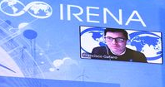
The International Renewable Energy Agency (IRENA) is an intergovernmental organization, established in 2011. Our mandate from our 170 member countries is to promote the adoption of renewable energy in a sustainable way. We have main headquarters in Abu Dhabi. We produce knowledge products, informing on best practices, on technologies, on cost. We also collect and share data on the development of renewables, and produce outlooks and scenarios of future, also related to climate change policies.
Within the energy transition, the power sector has a key role to play. If we look at today, around 20-25% of the final energy use is supplied by electricity. But in this decarbonization scenarios, it is expected that electricity will supply more than over 50% of the final energy use. Reliability and the cost efficiency of the power system is key and is critical for the whole energy transition to succeed.
An important component of the energy transition and of the power sector is the physical transformation, on the supply side. So, in decarbonization scenarios, it is expected that over 90% of the energy will come from renewables. Data from 2024 shows that there was an addition of almost 600 GW which represented around 92% of all new capacity additions at a global level was renewables. Almost 80% of that was solar and 20% was wind. So, we see that our power system is changing in terms of supply, but it's also expected to change in terms of demand. If we are talking about a shift on the share of electricity and final energy consumption, from 25% to 50%, it means that there would be an electrification of certain sectors. We have identified pathways in our outlook of which sectors may shift their energy usage to electricity, mainly will be building and transport, which will increase from 23% to 52%. Beside the electrification of the different sectors, we are also observing a deployment and potential exponential growth of new electricity consumers like data centers with this boom of artificial intelligence is also impacting the power sector and the power systems.
This electrification and these new loans, as well as the renewal, they represent a challenge on the power sector, because this is a big change. Also, there are opportunities there, which is what we should aim to achieve. This successful energy transition needs to guarantee that the power system is reliable and cost-efficient. It is not only about this transformation of the power sector and energy transition, it's not only about installing solar panels or wind turbines, these are only drivers, but it's really having system-wide applications. The demand and the generation are producing changes in the whole power system. So, we need the infrastructure to be able to deliver that power and to guarantee this efficiency. We also need to change regulations and policies in order to enable the development of that infrastructure.
Let's say that in early stages, the focus was on the renewables and how was the share of renewables increasing. But now, focus is on infrastructure that will enable the energy transition. One very important aspect is flexibility and we have made calculations to estimate how much flexibility is needed in the power sector at the global level to increase in different time scales and to maintain the reliability and cost efficiency. So, comparing to 2020 levels, the flexibility that we will need to manage the daily variability of variable renewables and demand will be around 10 times more if we look at a weekly timescale to manage how this net load changes.
Solutions are identified, so we can classify flexibility sources as supply-side flexibility, having flexible generation that enables me to handle this variability; we can have interconnections that allow me to share excess or to receive energy when I am short; we have storage, which allows us to shift the need for electricity and for infrastructure; we have the potential from four main elements or categories that can provide flexibility; we have the potential for demand for shifting when electricity is consumed, and then guaranteeing that will lead to reliable and cost-efficient power system. These elements should work together in a synergetic way to be able to explore each one of the elements in the renewables, and to look in a systemic way considering the particular context to define what we really need. This is how countries are beginning to move now, no one-fits-all solution but based on the particular needs and the context. Here, we are not only talking about the physical context of the electricity grids or the generation, but also the regulatory and the market context.
How does it work? Each power system should identify the best combination, or best way to combine flexible resources with the renewable resources to find a way for that integration. Here is an example of a study that we did in African countries. In all the African countries, with different combinations of solar and wind, in a decarbonization scenario. We looked at daily flexibility need to handle the weekly and seasonal deliverable. Systems where solar has predominance, they have higher daily needs at timescale flexibility and systems which are dominated by wind, their needs are higher at seasonal level. So, it's an indicator that, depending on what I have, I will need a different solution, and this is something that should be identified by the countries and plan for development of these solutions.
On top of the changes in generation, changes in demand, flexibility solutions, and the need to identify the most appropriate flexibility solutions, we have digitalization and the artificial intelligence as additional new elements to support energy transition. We categorize the benefits or uses of digitalization to improve the operation of the power system, and the integration of renewables to guarantee flexibility, reliability, and cost efficiency. We basically have five clusters –
- monitoring what is happening in the system,
- forecasting to manage the variability and compatibility,
- optimization of the use of the grid infrastructure,
- facilitating the automation of end-use for demand management,
- transparency.
So, this is like an additional element that should be considered, and should be integrated into the systemic planning of the energy transition.
In the case of the UK, there was an initial strong focus on short-term flexibility, for reserves and balancing. Still, stability is an issue, especially for their system, which is not strongly interconnected. But now, as they have their ambition for net zero, then they are looking at a roadmap for involving demand-side flexibility, customer-side flexibility, and options for long-duration storage. We all have witnessed the exponential increase that batteries have had, being useful and economically efficient to manage daily variability. But what if we have longer-term excess and shortages of energy, then we may need long duration storage. There are now policies incentivizing it in the UK, in California.
In 2025, the European Union established the methodology to make it mandatory for the countries to do flexibility planning. So, on top of their already existing transmission and generation plans, they are adding flexibility as a key element to enable this transition.
In COP29, in Baku, there was a pledge signed by several countries to increase the capacity of storage and also to increase the grids.
So, energy transition is not only adding renewables, but it's a systemic change in the whole power sector, but adding the infrastructure and creating the conditions for this infrastructure to work. It is not a one-fits-all solution, but it's something that should be suitable for every context.

PANKAJ BATRA, Senior Advisor, IRADe
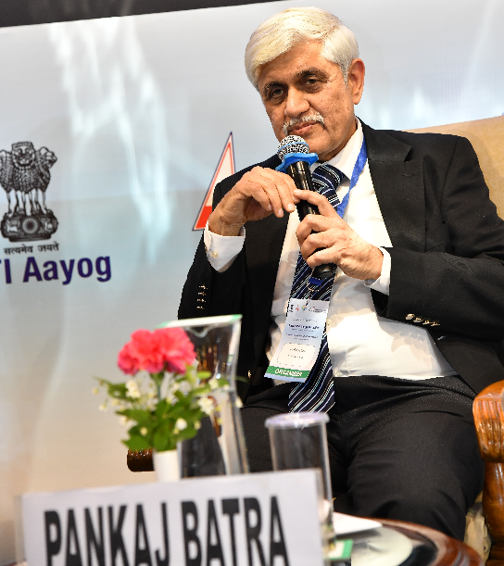
Load and generation has to be bulk balanced at each point of time. If the generation starts going down because of renewable sources like solar and wind, you have to make up that generation from some other source. It started in India, with flexible generation. Hydro itself is flexible as it is quick to respond within, less than a second, whereas coal-based generation is not. If generation goes down and the load remains the same, the operating frequency falls, and we have to stabilize the frequency, otherwise the grid would trip. So, these are principles of tackling intermittent generation, like wind and solar.
You also require storage because if you have excess generation during certain times of the day, you either curtail it or you store it Storage is the main device which would take care of this fluctuating generation, so as not to waste any renewable generation, which is free. There are also other ways of stabilizing the grid. Say, from the demand side, instead of generation following the load, you're given incentive for the demand side or a consumer to reduce the demand when there's less generation, and to increase the demand when there is more generation. So, basically, shifting of the demand. If somebody gets an incentive to do that, that's nothing like it, because you don't spend money on storage, or you don't spend money on flexibilizing generation.
Around 2000, European Union mandated that demand response should be treated equal to storage, and flexible generation. But it took some time to take off, and it's not fully taken off in Europe.
In India in 2016, we incorporated policy for installing smart meters, which would enable demand response. Even now, in India, after so many years, demand response has been recognized. Regulations for ancillary services now include demand response. However, it is not yet taken off, because this demand response has to be done where the consumers are, which is basically the states. Since we have a federal system, central government makes a policy but these have to be implemented at the state level, where it's still to take off. Demand response, is being done for interstate consumers, people who are connected to the interstate transmission system, which is not in the hands of the states. But that is very less.
Another method to balance generation and load in the cheapest manner is interconnections between countries, between regions, and connecting the whole world. That's the principle of one sun, one world, one grid, which Prime Minister Modi put forth, and later was followed by joint initiatives by the Prime Ministers of UK and Prime Ministers of India on Green Grid Initiative. These are methods which are there for seeing how to deal with this intermittent generation.
There's also flexibility in transmission and flexibility in distribution required, because transmission line would be loaded to some extent, for some time of the day to full load, but for most of the time to lesser load. That's inefficient utilization of transmission. And therefore, you have devices which would enable higher capacity utilization of transmission, which is flexible AC transmission devices. You have, not only active generation with changes, but also reactive generation with changes, and which has an adverse impact on the grid, on the voltage. So you can have phase-shifting transformers for seeing the two parallel lines are carrying unequal load, you can transfer the load from a higher loaded line to a lesser loaded line through phase-shifting transformers.
There is also dynamic line rating, where you can overload a line for a short period because intermittent generation would not be constant, and therefore, in solar peak hours, you can load it to an extent of 40% for new transmission lines for half an hour and you can extend the time. There are laws or formulae for determining to what extent you can load a line, which also depends on the wind speed at that time, because the wind tends to cool the line. You've got to stay within a certain temperature rise of these transmission lines.
Globally, demand response has taken off in Europe and, US, but not so in many other regions. In India having smart meters which would record consumption at different points of time during the day. So when smart meters, only about probably one-fourth of the consumers have been covered so far, but the intention is to cover the entire country, and then, you can have automated demand response. In India, demand response started through an aggregator model in Mumbai, in Tata Power, where it was an aggregator-based model, where the aggregator collected a number of demand consumers who were willing to reduce the load and get an incentive. And this was way back in about 2010-2011. Mumbai airport was a demand response consumer and they used to get paid around Rs 2.25 per unit for energy not consumed, that was the incentive. That was a pilot project. But if this takes off in a big way, you won't require half the amount of storage that you require now, or even less if you roll out demand response in a big way.
Since June 2020, you have a real-time market which has been brought into the power exchange in India, trying to utilize power when it is cheap and it is surplus, and not use power when it is costly. In the real-time market, you can buy and sell power for as little as about one and a half hours in advance, for as little as 15 minutes. In 2020, it was a small percentage of the day ahead market, but now it has become almost equal to the day-ahead market. So that's a change which has happened because people realize that it's a good way of balancing intermittent generation.

Question 1: You get a signal from the real-time market for demand response, wouldn't you get a much better signal if all the power goes through the market, to ensure that there isn't a huge amount of volatility? Would it make a difference if we had financially settled contracts and so all the power was in the market? Would you get a better price signal that way, and would the demand response be more effective in that case? Right now, the long-term contracts are settled separately and it's only a fraction, I think something like 7% or so goes through the market. So, if you had something higher than 7%, wouldn't you get a better price, a better signal for demand response?
Pankaj Batra: CFDs are financial contracts. This is to give assurance to the buyer and seller of predictable prices. So it doesn't actually deal with flexibility. It's just that people who want to hedge prices of renewables, they can hedge it through this mechanism. So it's a pricing and it’s not going to encourage how to deal with flexibility. Handling flexibility is a technical thing, irrespective of the price. CFD is an assurance of price, which you get through financial contracts, but the intermittency is not tackled that way. The real-time market is helping that from the point of view of people being encouraged to buy more power, or use more power when the prices are low, and not use more power when the prices are high. When I'm talking about the demand response, I'm modulating the megawatt, not the energy. On the automated demand response system, we are connecting with the SLDC. SLDC is going to give us the signal, and we can actually use the demand for the financial benefit.
In IRADe, we had done work on various Indian states and what is their renewable shares, and how we can increase. There's huge variations with states like Himachal Pradesh who have more than 80%, and there were Gujarat, Rajasthan reaching more than 50%. Even large states like UP have less than 20% renewable share but has a lot of potential, especially if they do some distributed generation, and then there are certain pockets in UP where land is also available. Similarly, Haryana is also very low on renewables. CEA has done a state-specific study, and they have come out with figures on how much potential each state has, and how much they should generate from within the state, and how much they should get from other states. And then they have been in discussion with various states so that in case states feel that they don't want to import from other states, they want to generate employment, or maybe get investments within the state, then they should at least harness whatever potential is available within the state.

Question 2: Will peer-to-peer trading act as a balancing mechanism?
Pankaj Batra: No, peer-to-peer trading is when somebody owns a rooftop solar and is not able to utilize it, so instead, the power goes to another consumer. So it doesn't upset the load generation balance. When it goes to another consumer, that person will off-take less from the utility. If you're getting it from the grid at 7 rupees per unit, and somebody's selling it to you for 3 rupees, you reduce your bills.

